INFORMATION SECURITY PROJECT REPORT
Submitted By:
Ayesha Shaikh (24BSSW022)
Sharjeel Ahmed (24BSSW014)
Syed Abdul Wahab (24BSSW016)
Class: SE-B
Batch: 2024th
Subject / Course: Information Security
Submitted To: Dean Dr. Zahoor Shah
Submission Date: 12-11-2026
Project: Secure Library Management System
Group: 03 “Secure Library Management System”
Table of Contents
- Executive Summary
- Introduction and Background
- Problem Statement
- Aim, Objectives and Scope
- Requirements Specification
- Users, Roles and Access Control
- System Analysis and Workflow
- System Architecture and Technology
- Database Design
- Implementation Details
- Information Security Design
- Testing and Verification
- User Interface and Screenshot Evidence
- Installation and Operation
- Limitations and Risk Considerations
- Future Enhancements
- Conclusion
- References and Appendices

- Executive Summary
The Secure Library Management System is a browser-based application intended to digitize routine library activities while separating the permissions of students, librarians, and administrators. The delivered application is implemented using PHP, MySQL, HTML, CSS, JavaScript, and Bootstrap. It provides account registration and sign-in, a searchable book catalogue, borrowing requests, librarian approval and return processing, user administration, system settings, reports, CSV export, and an activity log.
The application uses a relational database named secure_library. Its schema includes users, categories, books, borrowings, activity_logs, login_attempts, and system_settings. The code includes password hashing and verification, prepared PDO statements, server-side role checks, CSRF validation for POST actions, session-cookie protections, login-attempt throttling, input handling, foreign-key constraints, transactional stock updates, and audit logging.
The project follows the proposal’s central objective: provide a user-friendly library platform and protect library records through authentication, role-based access, and controlled transactions. The screenshots illustrate the student, librarian, and administrator interfaces, as well as registration and login error states.
This is an academic demonstration application rather than a production-ready institutional deployment. Its README explicitly recommends HTTPS, a dedicated database account, credential rotation, backups, restricted infrastructure access, and a full security review before public deployment.
- Introduction and Background
Libraries support teaching and learning by making books and other educational resources available to students and staff. In a manual or register-based environment, staff may need to search physical records, update stock by hand, and separately track issue and return dates. As the number of users and books grows, these tasks become time-consuming and can lead to inconsistent or missing records.
The proposal identifies the need for a centralized web application that lets students search for books, check availability, request borrowing, return books, and review their own records. It also calls for librarian functions to manage books and transactions, and administrator functions to manage accounts, permissions, monitoring, and reports.
The implemented system organizes these tasks into role-specific pages. It is accessed through a modern web browser and is designed to run locally using XAMPP, Apache, PHP, and MySQL
- Problem Statement
The project addresses the following issues identified in the proposal:
- Book records may be maintained manually, making updates difficult to coordinate.
- Finding a particular book or confirming availability can take time.
- Borrowed and returned books may be difficult to track consistently.
- Physical records may be lost, damaged, or incorrectly maintained.
- Student and teacher information may be exposed if records are accessed by unauthorized people.
- Librarians may spend unnecessary time managing routine borrowing records.
- Accurate summaries and reports may be difficult to prepare from paper records.
- The proposed response is a centralized digital catalogue and transaction register with authenticated accounts and role-based permissions.
- Aim, Objectives and Scope
- Aim
To develop a user-friendly, secure, and efficient web application that automates library management activities, provides convenient access to library information, and limits access to authorized users.
- Objectives
- Provide a web-based platform for library resources.
- Allow students to search by book title, author, ISBN, or category and view availability.
- Support borrowing requests, librarian approval, return requests, and librarian-recorded returns.
- Allow students to view current borrowing records and borrowing history.
- Enable librarians to add, edit, and delete eligible book records and manage transactions.
- Enable administrators to manage user accounts, roles, account status, settings, and reports.
- Maintain accurate book-copy counts and borrowing records.
- Reduce manual record keeping and prevent unauthorized changes through authentication and access checks.
- Scope included in the delivered application
Module | Implemented capabilities evidenced in source
Student | Self-registration as a student; sign-in; search and filter catalogue; view stock; request a book; view personal borrowings; request a return.
Librarian | View and manage catalogue; add/edit/delete eligible book records; review pending borrowing requests; approve/reject requests; directly issue a book; record physical returns; view transactions.
Administrator | Create and update user accounts; assign roles and active/inactive status; reset passwords; view dashboard and reports; inspect activity logs; export borrowing records to CSV; configure loan limits and duration.
Out of scope: The proposal excludes online payment gateways, e-book reading, a dedicated mobile application, barcode/RFID integration, and integration with external library networks. These are not presented as delivered features in the source package.
- Requirements Specification
- Functional requirements
ID | Requirement | Delivered implementation / evidence
FR-01 | User login | login.php verifies credentials and account status.
FR-02 | User authentication | Session-based login, password verification, and protected-page checks.
FR-03 | Book search | Catalogue filters support title/author/ISBN/category searches.
FR-04 | Book details | Catalogue displays book details including author, ISBN, category, copy totals, and availability.
FR-05 | Book borrowing | Student submits a request; librarian approves/rejects or issues directly.
FR-06 | Book returning | Student can request return; librarian records the physical return.
FR-07 | Borrowed books | Student transaction page lists their borrowing records and statuses.
FR-08 | Book management | Librarian/admin-authorized catalogue actions add, edit, and delete eligible records.
FR-09 | User management | Admin-only page creates and updates accounts, roles, and status.
FR-10 | Reports | Admin report page summarizes borrowing activity and provides CSV export.
- Non-functional requirements
Quality attribute | Project interpretation
Usability | Clear navigation, dashboards, catalogue filters, status badges, and responsive Bootstrap styling.
Security | Password hashing, authentication, role checks, CSRF checks, session-cookie protections, and login throttling.
Performance | Uses indexed relational tables and normal web/database requests; no formal performance benchmark was supplied.
Reliability | Foreign keys and database transactions help maintain consistent records and stock updates.
Availability | The application is available while the local web/database services are running; no uptime guarantee or monitoring service is included.
Maintainability | PHP modules are separated by function and shared configuration/layout code is reused.
Compatibility | Designed for modern browsers and responsive layouts; no formal browser test matrix was supplied.
- Users, Roles and Access Control
Role | Responsibilities and permissions
Student | Register and sign in; browse/search the catalogue; view availability; request borrowing; view own loans/history; request return.
Librarian | Manage book inventory; approve or reject borrowing requests; directly issue books; record physical returns; view transaction records.
Administrator | Manage users and roles; activate/deactivate accounts; reset passwords; view system reports and activity log; export borrowing CSV; configure loan policy settings.
Role enforcement is performed on the server through require_role() in config.php and role-specific checks in protected modules. The code refreshes the current account’s role and status from the database when a protected page is opened. An inactive or missing account is signed out and redirected to login.
Public registration creates a Student account; the registration form does not allow a visitor to grant themselves librarian or administrator privileges. Administrative account creation and role changes are handled in users.php.
- System Analysis and Workflow
- Student borrowing workflow
- The student opens the application and signs in, or registers a student account.
- The student opens the book catalogue and searches by relevant details.
- The system displays matching books and available-copy information.
- The student submits a borrowing request for an available book.
- The request is saved with a pending status and becomes visible to the librarian.
- The librarian approves or rejects the request. On approval, the issue date and due date are recorded and stock is updated.
- The student can view the updated loan status and later submit a return request.
- The librarian confirms the physical return, records the return date, and restores the available-copy count.
- Librarian workflow
The librarian signs in, reviews the dashboard and catalogue, and uses the transaction register to process student requests. The librarian can approve or reject pending requests, issue a book directly to a student, and record a return after the physical book is received. Catalogue maintenance includes adding new records, editing existing records, and deleting records only when referential history permits.
- Administrator workflow
The administrator signs in to a protected dashboard, manages user accounts and their roles/status, reviews reports and audit activity, exports borrowing records, and configures the maximum pending/active loans and loan period. The source defaults are three pending or active loans and a 14-day loan period; both are configurable in System settings.
- Transaction statuses
The database defines the borrowing statuses pending, borrowed, return_requested, returned, and rejected. These statuses represent the stages of the borrowing lifecycle. The interface displays status labels to help staff and students distinguish the current state.
- System Architecture and Technology
The project uses the three-tier architecture
Layer | Technologies / responsibility
Presentation layer | HTML5, CSS3, Bootstrap, JavaScript and Bootstrap Icons; provides the browser interface.
Application layer | PHP; handles authentication, role checks, catalogue actions, borrowing rules, reports, and business logic.
Database layer | MySQL; stores user accounts, categories, books, borrowing transactions, activity logs, login attempts, and settings.
User / Browser → HTML/CSS/Bootstrap interface → PHP application → MySQL database
The config.php file initializes the timezone, session settings, PDO connection, role and login helpers, CSRF utilities, audit logging, and configurable library settings. The individual PHP pages separate the dashboard, catalogue, transactions, users, reports, settings, login, and registration functions.
- Technology stack
Technology | Use in this project
HTML5 | Page structure and forms.
CSS3 | Custom interface styling in assets/css/style.css.
JavaScript | Client-side interface interactions in assets/js/app.js.
Bootstrap | Responsive layout, controls, and interface icons.
PHP | Server-side logic and page rendering.
MySQL | Relational data storage.
XAMPP | Local Apache/PHP/MySQL development environment.
Visual Studio Code | Code editing and project development.
The application loads some front-end assets from CDNs, including Bootstrap-related assets, Google Fonts, and Chart.js.
- Database Design
The database.sql creates the secure_library database using InnoDB and utf8mb4. It creates seven application tables. Primary keys uniquely identify records, foreign keys connect related records, and indexes support common lookups.
Table | Key fields and purpose
users | user_id (PK), name, email (unique), password hash, role, status, created/updated timestamps.
categories | category_id (PK), category_name (unique); organizes book subjects.
books | book_id (PK), title, author, ISBN (unique), category_id (FK), total_copies, available_copies.
borrowings | borrowing_id (PK), user_id (FK), book_id (FK), issue_date, due_date, return_date, status, processed_by (FK).
activity_logs | log_id (PK), user_id (FK, nullable), action, details, IP address, timestamp.
login_attempts | attempt_id (PK), email, IP address, attempt count, last_attempt; unique email/IP pair.
system_settings | setting_key (PK), setting_value, description, updated_by (FK), updated_at.
- Relationships
- One user can have multiple borrowing records.
- One book can appear in multiple borrowing records over time.
- One category can contain multiple books.
- Each borrowing record links one student/user to one book.
- A borrowing record may identify the staff member who processed it.
- Activity log and settings references can be set to NULL if the related user is removed, according to the schema.
- Integrity rules
The schema uses unique constraints for email, ISBN, category name, and settings keys. Foreign keys protect related records. A CHECK constraint prevents available_copies from exceeding total_copies. The source uses database transactions around important stock and transaction operations, and prevents deletion of books that have borrowing history so historical records are retained.
- Implementation Details
- Authentication and account lifecycle
The registration module creates student accounts and stores passwords using PHP password_hash() with PASSWORD_DEFAULT. During login, password_verify() checks the submitted password against the stored hash. Successful sign-in is logged. The code also includes handling for unsuccessful login attempts and a temporary wait after too many failures, as illustrated by the supplied error-state screenshot.
- Catalogue management
The catalogue supports search and filtering and displays book metadata and stock. Authorized staff can add or update a record. Deletion is constrained where borrowing history exists, preserving the links needed for transaction history. Student catalogue views expose request actions for available books rather than staff maintenance controls.
- Borrowing and returns
A student borrowing request is recorded as pending. The librarian may approve or reject it. Approval records the issue and due dates and updates stock within a database transaction. A student return request changes the transaction state to return_requested; the librarian’s record-return action confirms the return date/status and updates available copies. Direct issue by a librarian is also implemented.
- User administration
The admin-only user management module creates accounts, updates names and email addresses, changes role and account status, and supports password reset through a newly hashed password. Server-side authorization prevents non-administrators from using this page.
- Reports and system settings
The admin report page presents a borrowing summary, recent borrowing records, and recent audit activity. It supports exporting transaction details as CSV, including transaction ID, student, book, dates, status, and processor. System settings allow the administrator to configure the maximum pending/active loans per student and the loan period in days.
- Shared interface
The application uses shared header and footer components for consistent navigation and page layout. The visual theme includes a left navigation area, dashboard cards, catalogue tables, forms, and status labels. The screenshots show separate dashboard content for each role.
- Information Security Design
The proposal frames security around confidentiality, integrity, and availability (CIA). The source code provides several concrete controls relevant to confidentiality and integrity. Availability is primarily dependent on the local hosting environment; the project does not include high-availability infrastructure.
Security control | Evidence in supplied implementation | Security contribution / qualification
Password hashing | password_hash() at registration and admin account creation/update; password_verify() at login. | Avoids storing plaintext passwords. Hashing is not the same as encrypting student data.
Prepared statements | PDO prepared queries with emulated prepares disabled. | Reduces SQL injection risk when used consistently.
Role-based access | require_role() and protected-page checks in PHP. | Restricts privileged functions on the server, not only in the interface.
CSRF protection | csrf_token() and verify_csrf() on state-changing POST forms. | Helps prevent cross-site request forgery for protected form actions.
Session protections | Session ID regeneration at login; HTTP-only and SameSite=Strict cookie settings; Secure flag when HTTPS is detected. | Reduces some session theft and cross-site request risks. HTTPS still needs to be configured in deployment.
Login throttling | login_attempts table and failed-attempt handling. | Slows repeated guessing; it is not a substitute for a broader identity security policy.
Audit logging | audit_log() writes user, action, details, IP address, and timestamp. | Provides an activity trail; logs are not described as cryptographically tamper-proof.
Database integrity | Foreign keys, unique constraints, copy-count check, and transactions. | Helps preserve referential and stock consistency.
Output escaping | e() uses htmlspecialchars() for HTML output. | Helps mitigate HTML/script injection when applied to untrusted output.
- CIA mapping
CIA principle | How the system addresses it | Boundary
Confidentiality | Authenticated access, role restrictions, password hashing, session controls, and output escaping. | The supplied code does not establish encryption of all student data at rest or in transit. HTTPS must be configured for network deployment.
Integrity | Prepared statements, CSRF tokens, foreign keys, validation, transactional stock updates, and audit events. | Audit logs are application records; no cryptographic tamper-evidence mechanism is shown.
Availability | Local application can be accessed while Apache and MySQL are running; code handles database connection failure with an error response. | No failover, uptime monitoring, automated backup service, or continuous availability guarantee is implemented.
- Testing and Verification
The proposal lists unit, integration, system, functional, security, and usability testing. It also specifies expected outcomes for login, search, borrowing, return, and viewing borrowed books. The source package includes implementation code and screenshots of representative pages and error states, but it does not include a formal automated test suite or signed test execution results. The table below therefore distinguishes test cases that can be derived from the requirements from evidence visible in the materials.
Test ID | Test scenario | Expected result from proposal / application logic | Evidence status
TC-01 | Sign in with correct credentials | Authorized user enters the role-appropriate workspace. | Login and role dashboards shown in screenshots; demo credentials documented in README.
TC-02 | Sign in with incorrect credentials | An error message is displayed; access is not granted. | Incorrect-login screenshot supplied.
TC-03 | Repeated unsuccessful sign-ins | Temporary throttle message is shown after too many failures. | Too-many-failed-attempts screenshot supplied.
TC-04 | Register a student account | Account is created with Student role and success confirmation is shown. | Registration and registration-success screenshots supplied; source confirms student role.
TC-05 | Search for an existing book | Matching catalogue records are displayed. | Catalogue screens supplied.
TC-06 | Search for a missing book | No-results state is displayed. | No dedicated screenshot or test log supplied.
TC-07 | Request an available book | A pending borrowing request is recorded. | Student borrowing screen shows request confirmation; source implements request_borrow.
TC-08 | Approve a pending request | Loan is recorded with issue/due dates and stock is updated. | Librarian transaction screen supplied; no independent execution log supplied.
TC-09 | Reject a pending request | Request status becomes rejected. | Source action exists; no dedicated rejection screenshot supplied.
TC-10 | Request and record a return | Return request is visible; librarian records return and stock increases. | Librarian transaction screens supplied; source implements both actions.
TC-11 | Attempt privileged page as unauthorized role | Server denies access. | Role checks are present in source; no dedicated denial screenshot supplied.
TC-12 | Export borrowing report | CSV file is generated for transaction records. | Source implements CSV export; no export file supplied.
- Testing conclusion
The Screenshots evidence supports the presence of the major user interfaces and the key code paths described above. A complete verification exercise should still run each test case on a clean local installation, record actual inputs and outputs, capture pass/fail results, and test role boundaries and security controls directly.
- User Interface and Screenshot Evidence
This section includes images / screenshots of website developed. Each caption describes the visible page or state and its role in demonstrating the application. Screenshots are grouped by their original archive folders.
- Registration and login
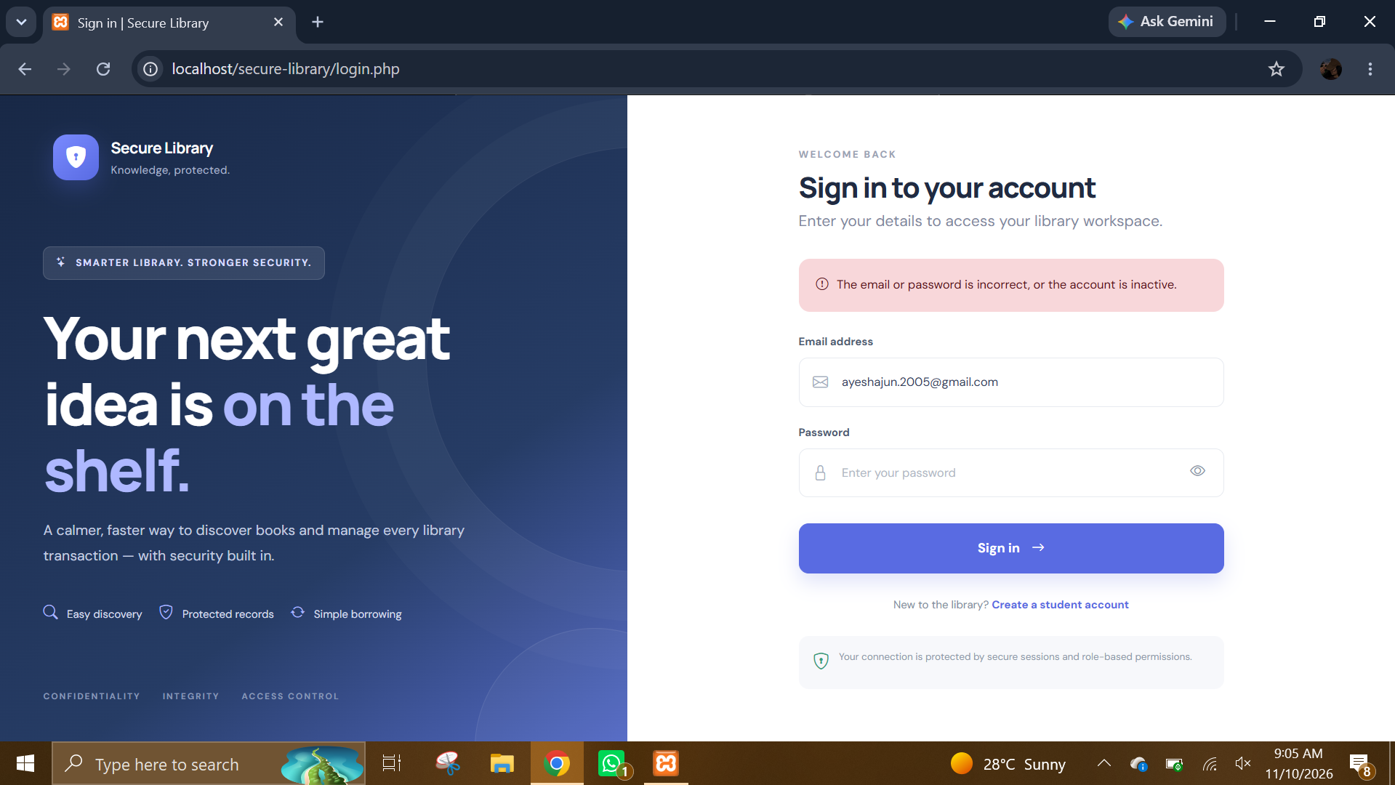
INCORRECT LOGIN.PNG: Invalid-credential feedback. The sign-in page displays an error and does not grant access when the supplied credentials are incorrect or the account is inactive.
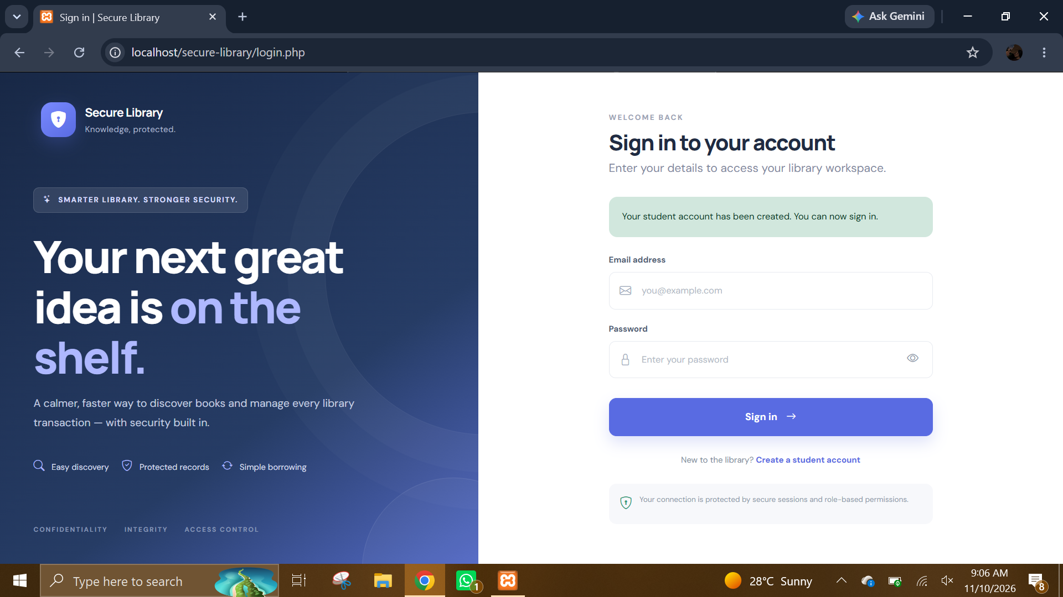
REGISTER 2.PNG: Registration confirmation displayed on the sign-in page. It indicates that the student account was created and can now be used to sign in.
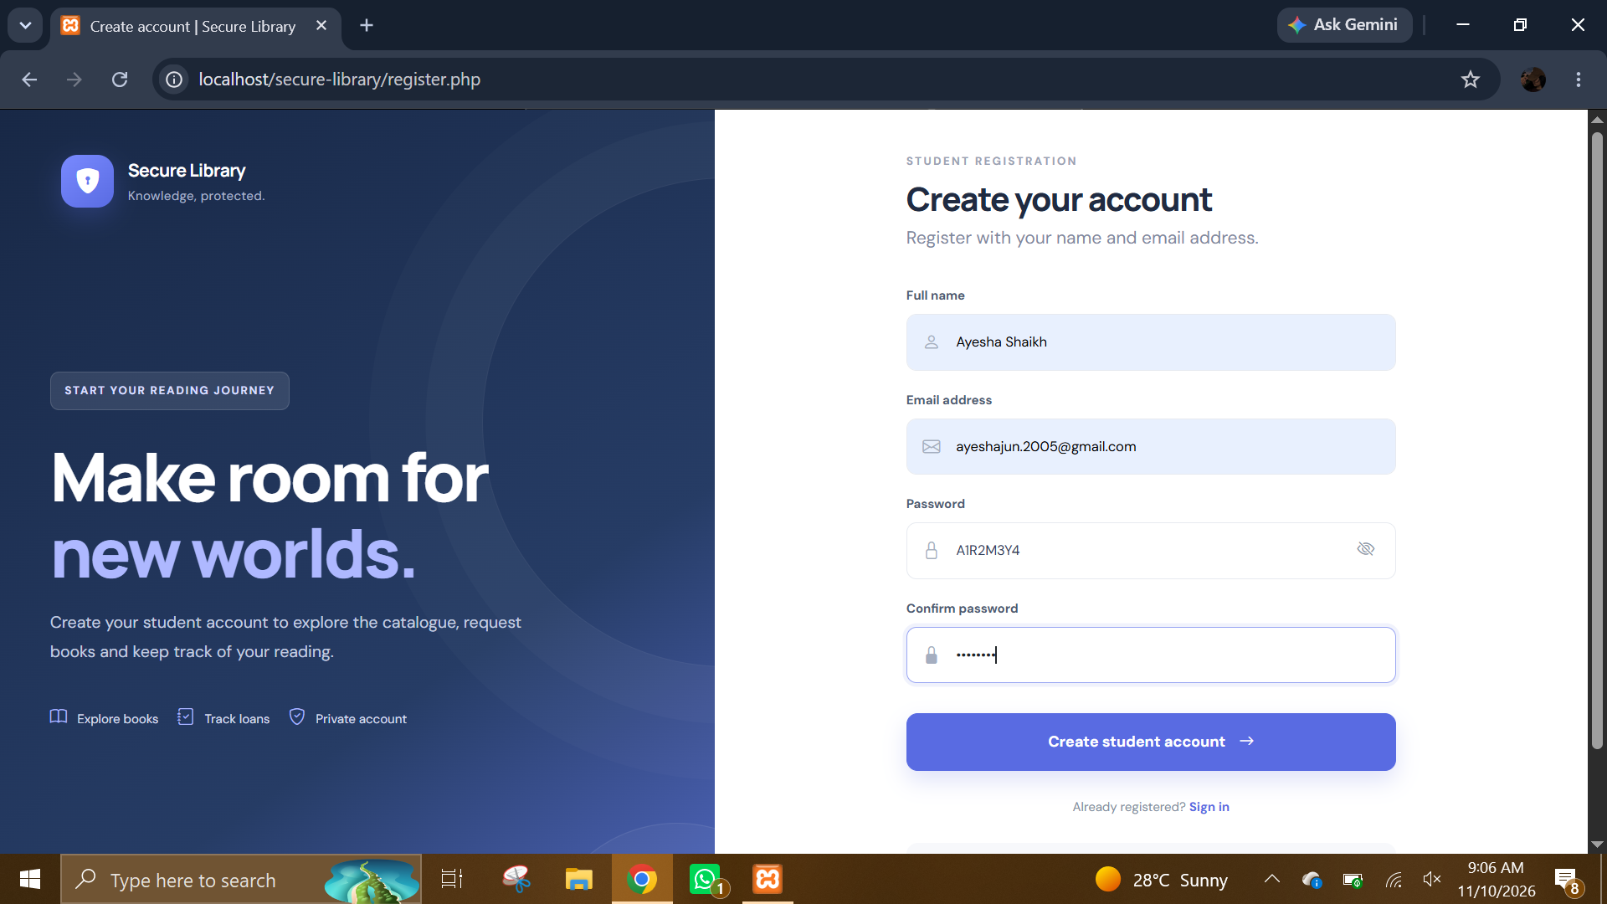
REGISTER.PNG: Student registration form. The screen collects the name, email address, and password needed to create a student account.
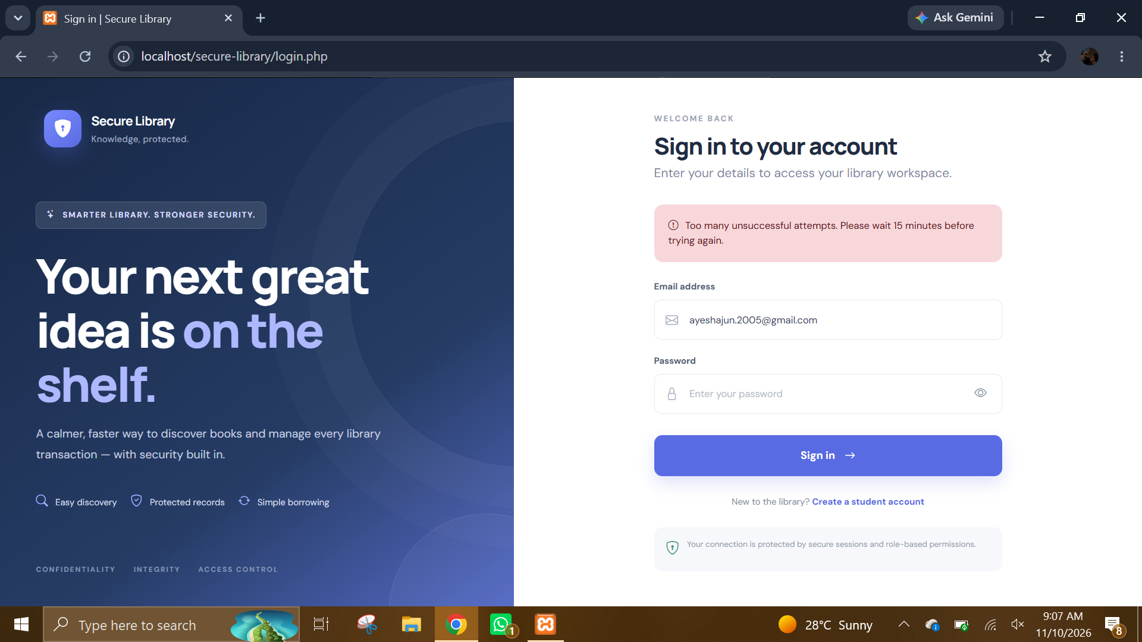
TOO MANY FAILED ATTEMPTS.PNG: Login-throttling feedback. The interface asks the user to wait after too many unsuccessful attempts, illustrating the application's basic brute-force mitigation.
- Administrator interface
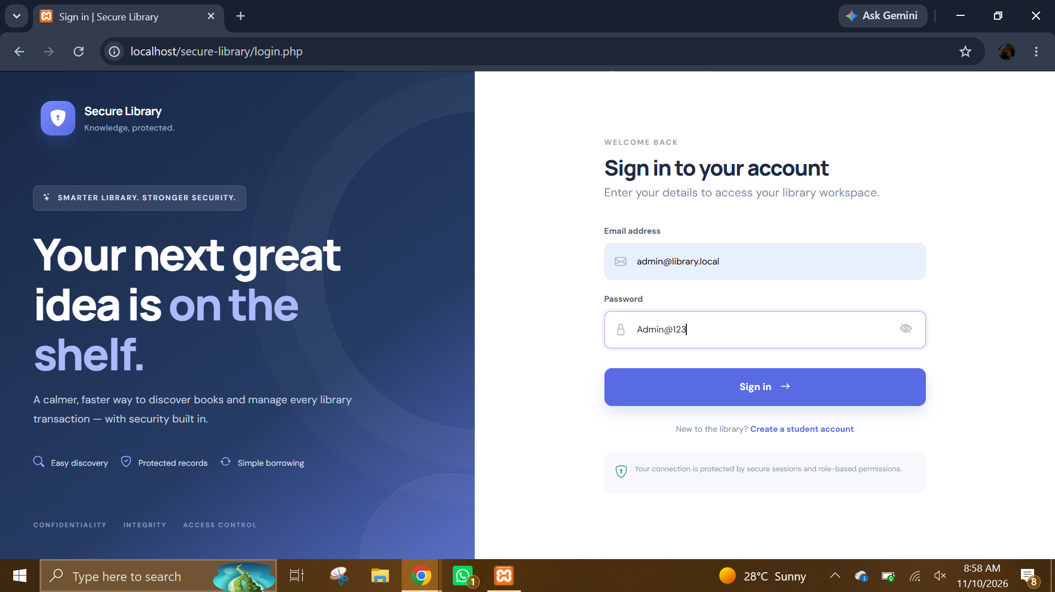
admin 1.PNG: Administrator sign-in page. This is the common authentication entry point used to access the protected administrator workspace.
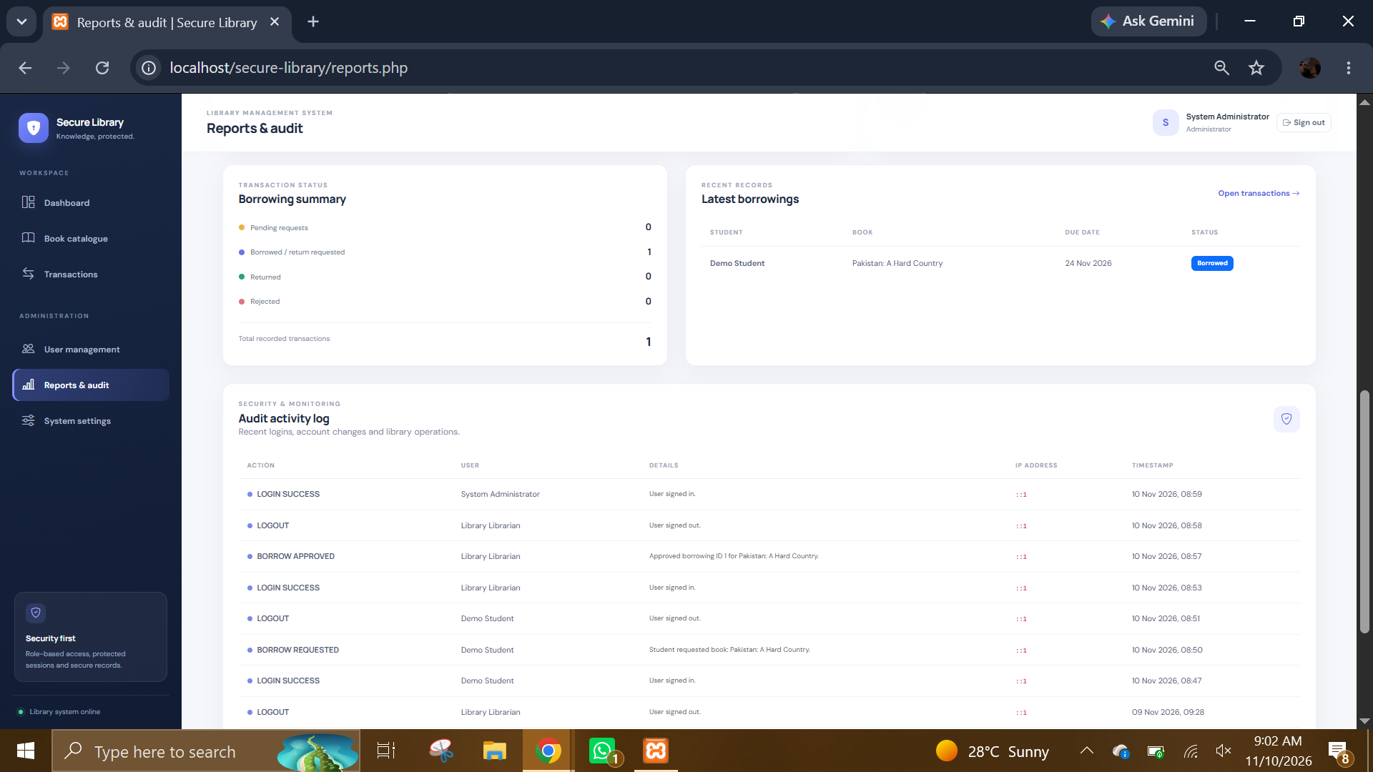
admin 10.PNG: Reports and audit detail. This view shows borrowing summaries, recent borrowing records, and the audit activity section.
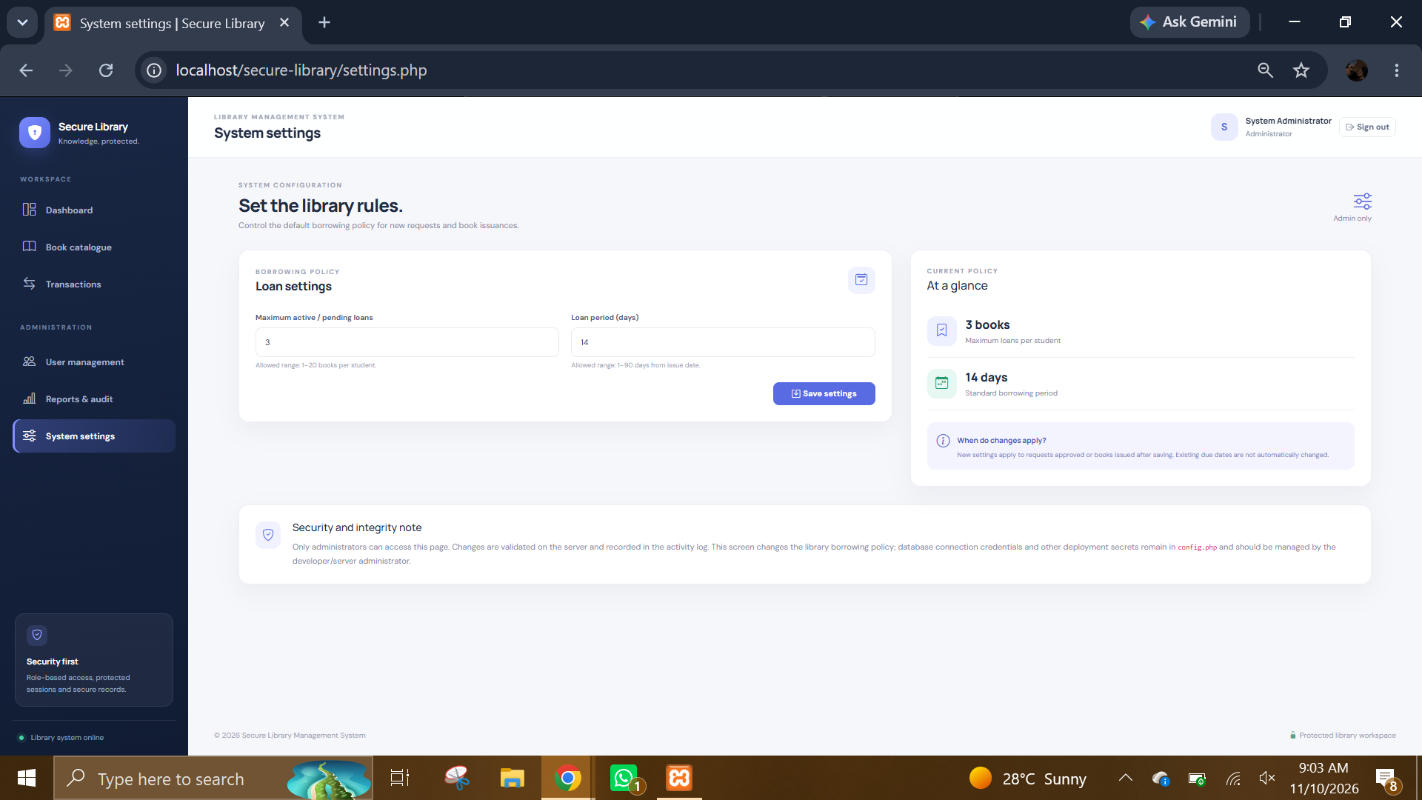
admin 11.PNG: System settings page. It exposes configurable library rules, including the maximum pending/active loans and the loan period.
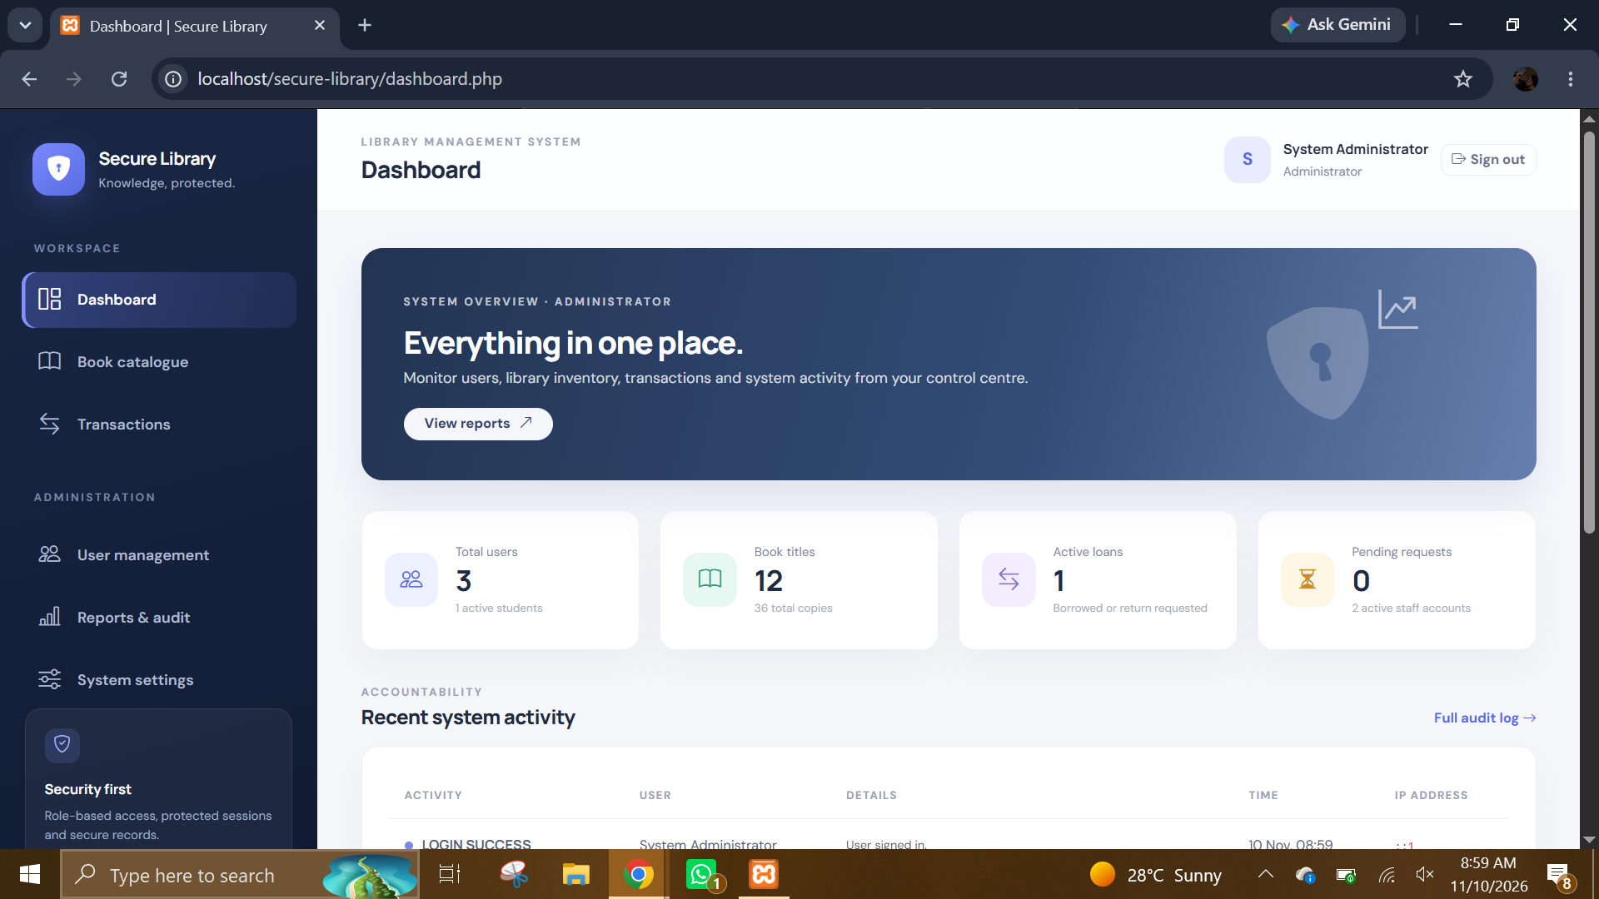
admin 2.PNG: Administrator dashboard. It provides a central overview and navigation to catalogue, transactions, user management, reports, and system settings.
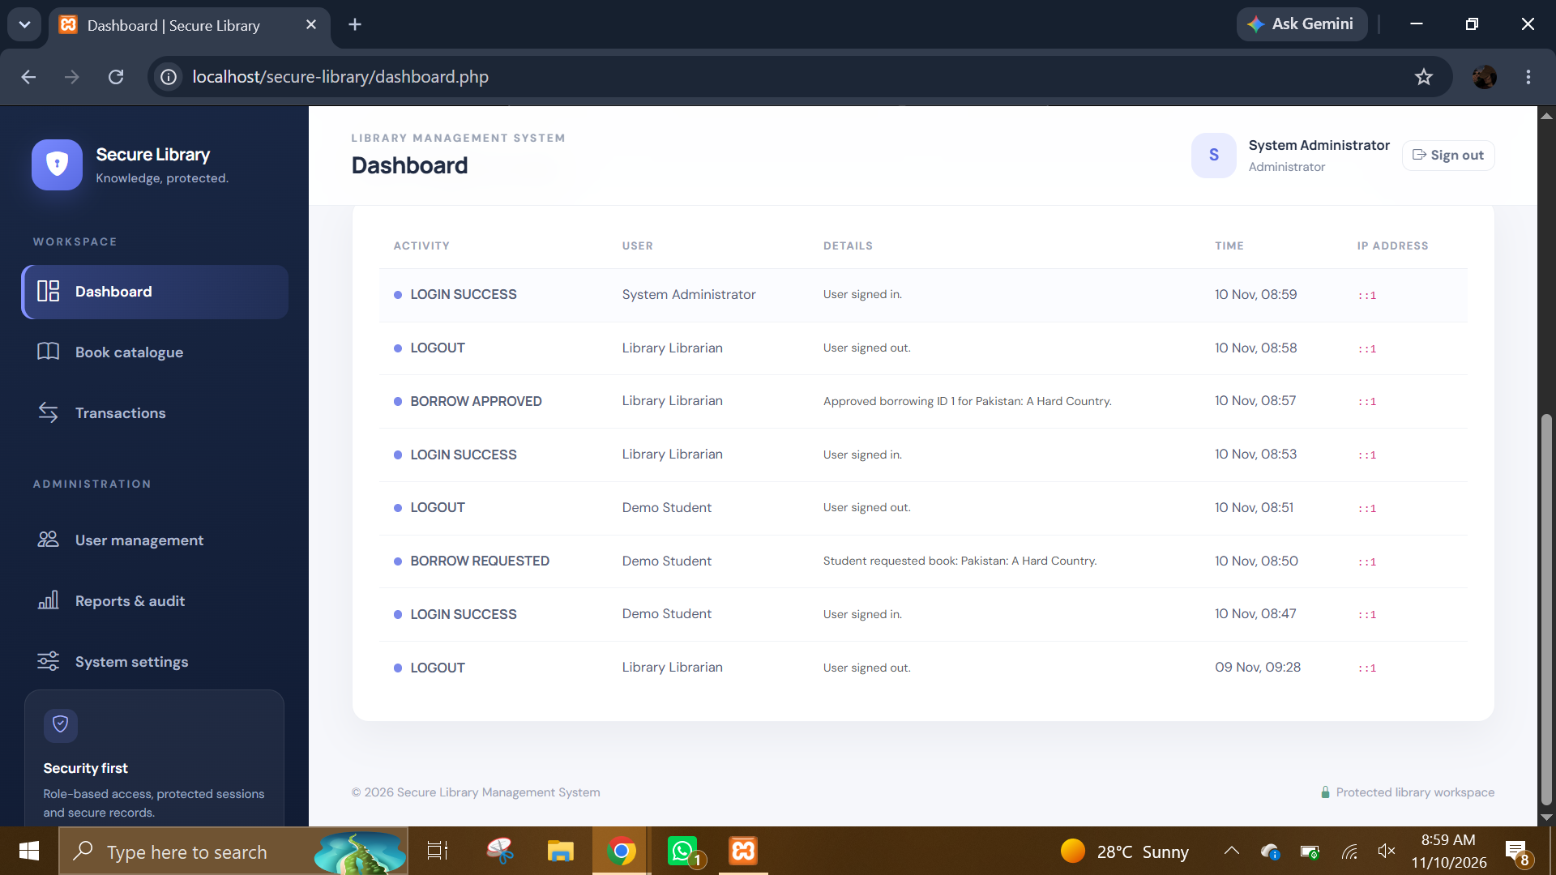
admin 3.PNG: Administrator activity view. The visible activity entries include sign-in and sign-out events, demonstrating the audit/activity history.
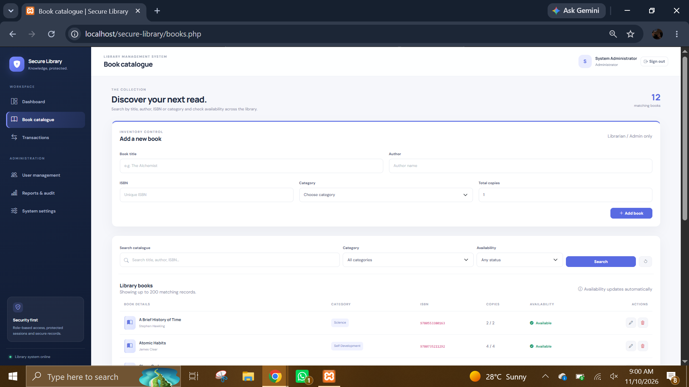
admin 4.PNG: Book catalogue with the add-book form. The administrator can view the catalogue and enter a new book record, including its bibliographic and stock details.
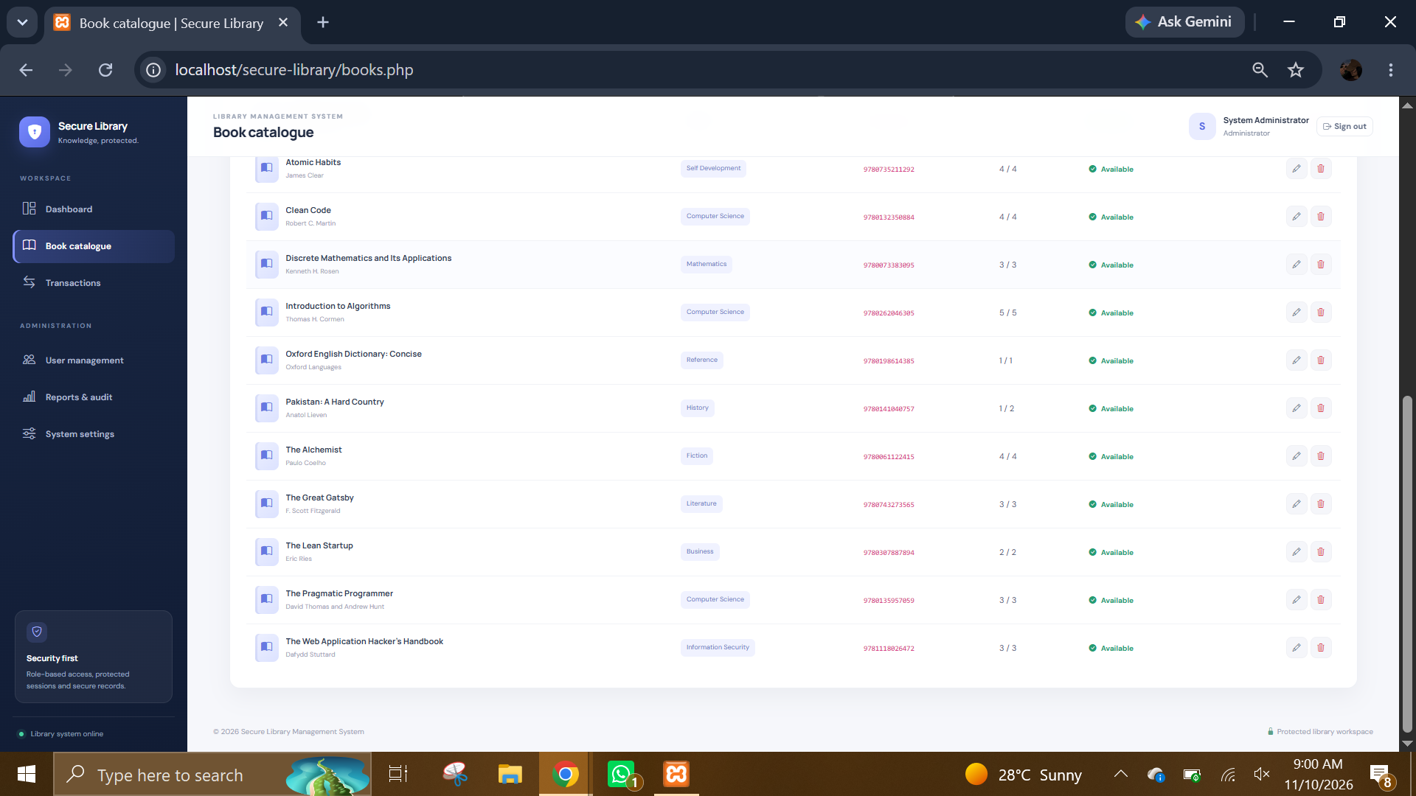
admin 5.PNG: Book catalogue listing. The page presents stored book records and catalogue navigation; the view demonstrates centralized inventory information.
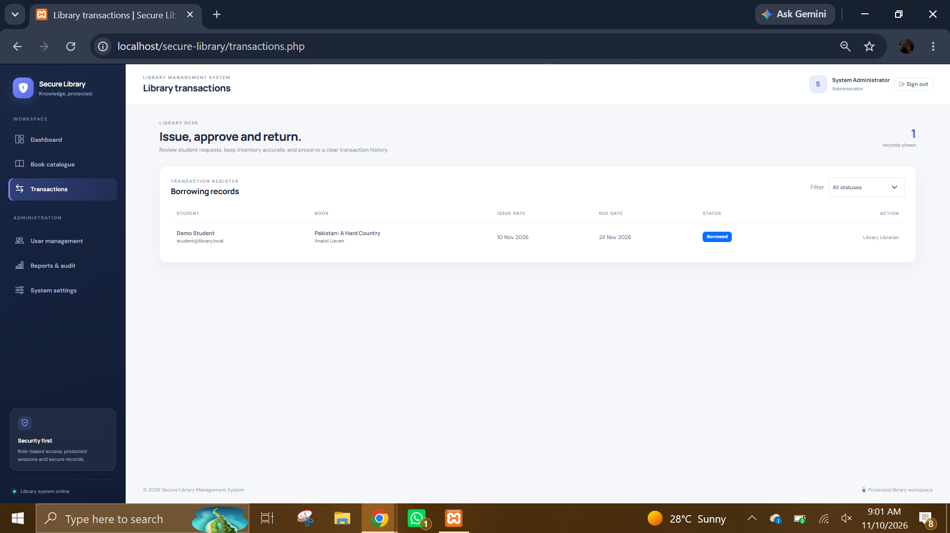
admin 6.PNG: Library transactions page. The page presents borrowing records and transaction-management controls for reviewing and processing loans.
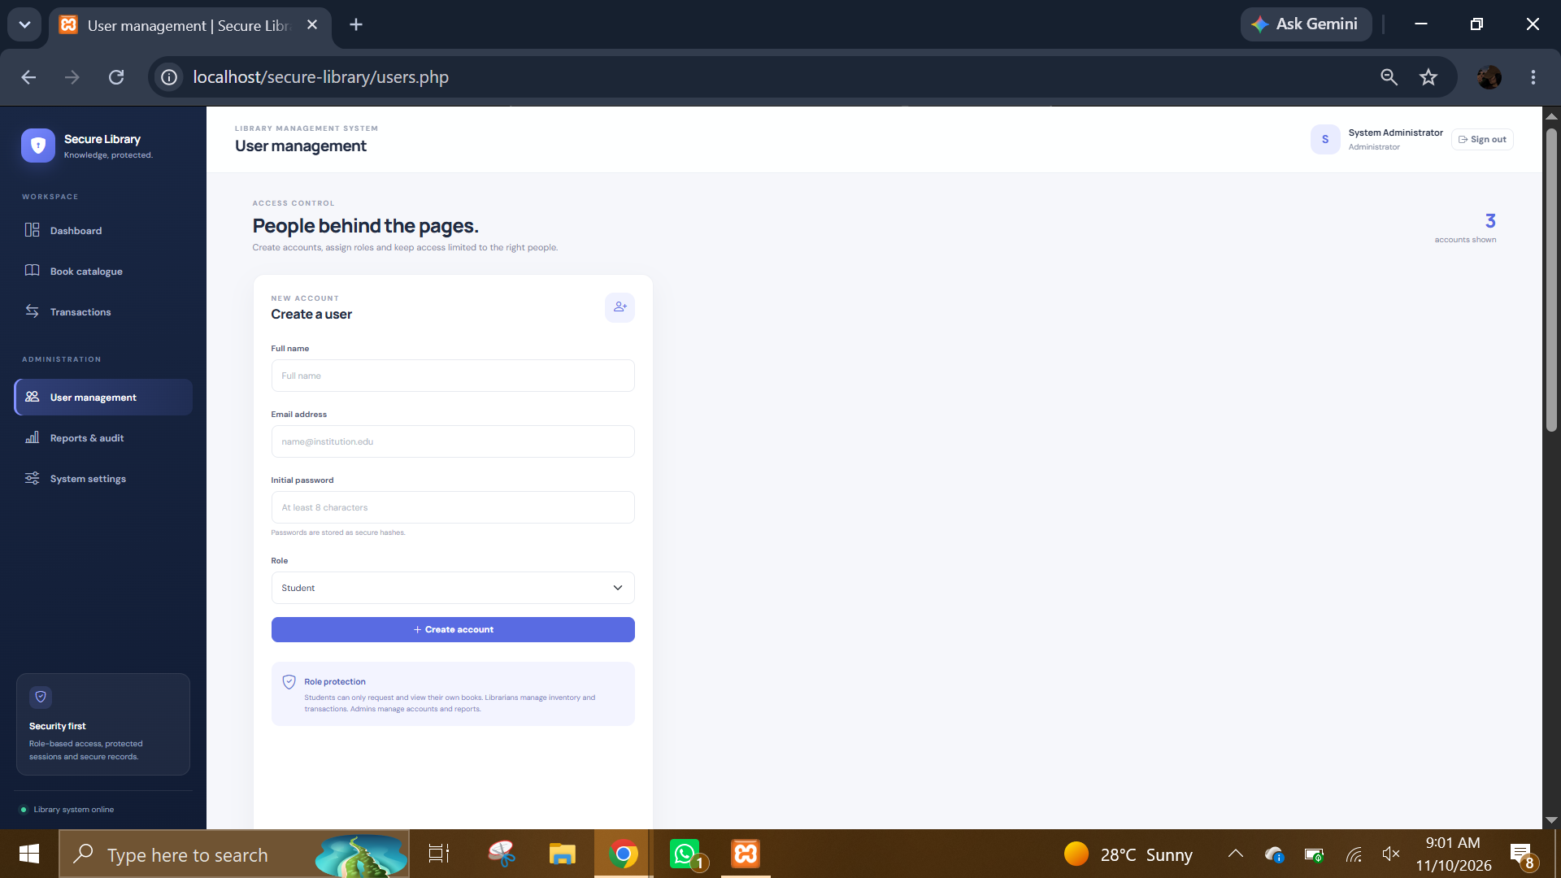
admin 7.PNG: User management form. The administrator can create a user account and select account details and role.
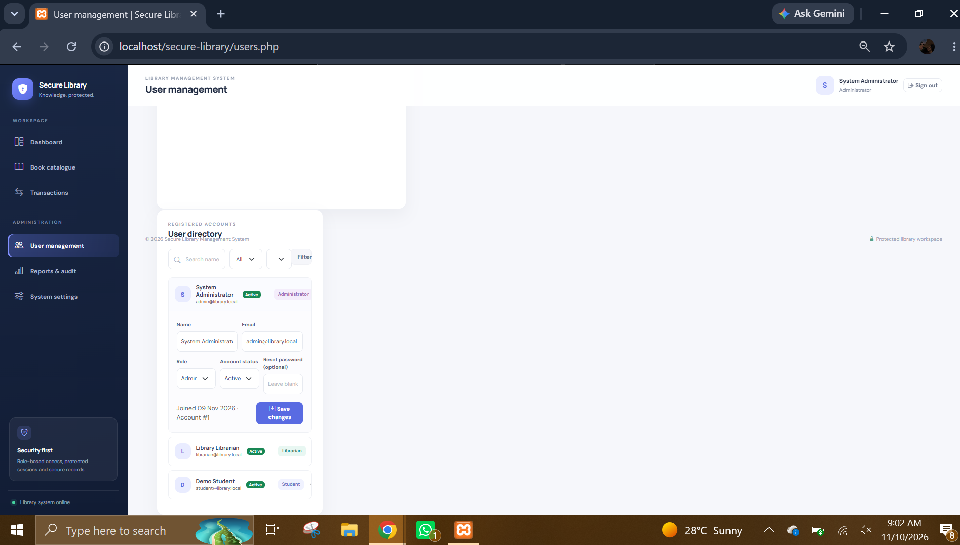
admin 8.PNG: User management listing. The page provides access to existing user accounts and their account-management controls.
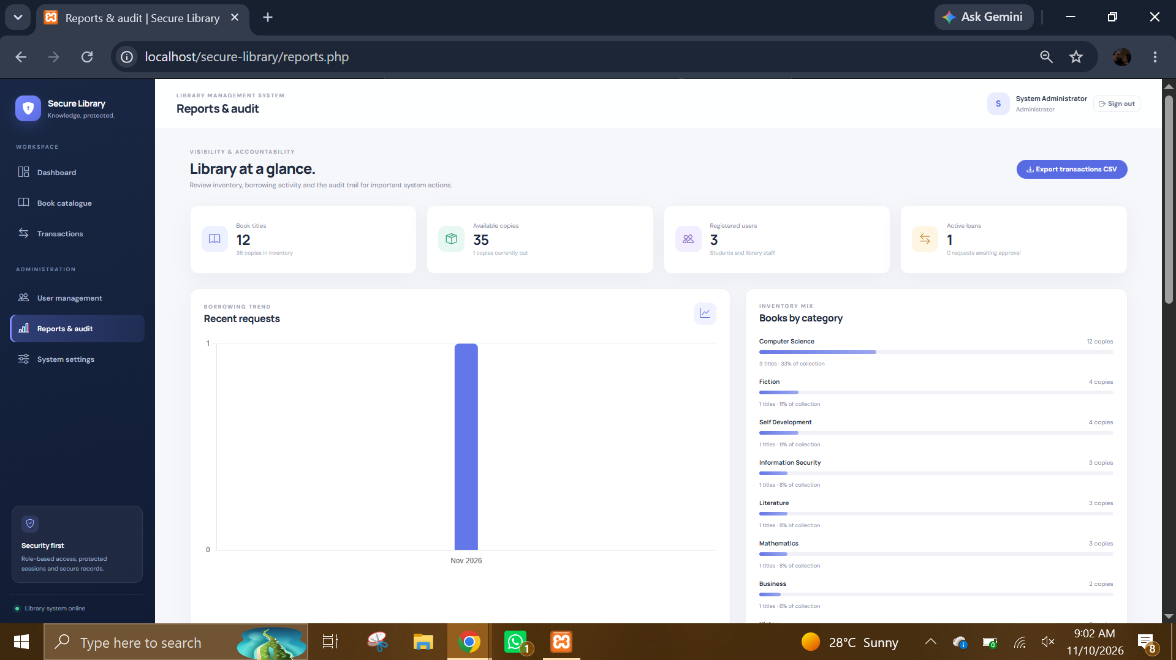
admin 9.PNG: Reports and audit dashboard. It summarizes borrowing activity and provides recent transaction and activity information.
- Librarian interface
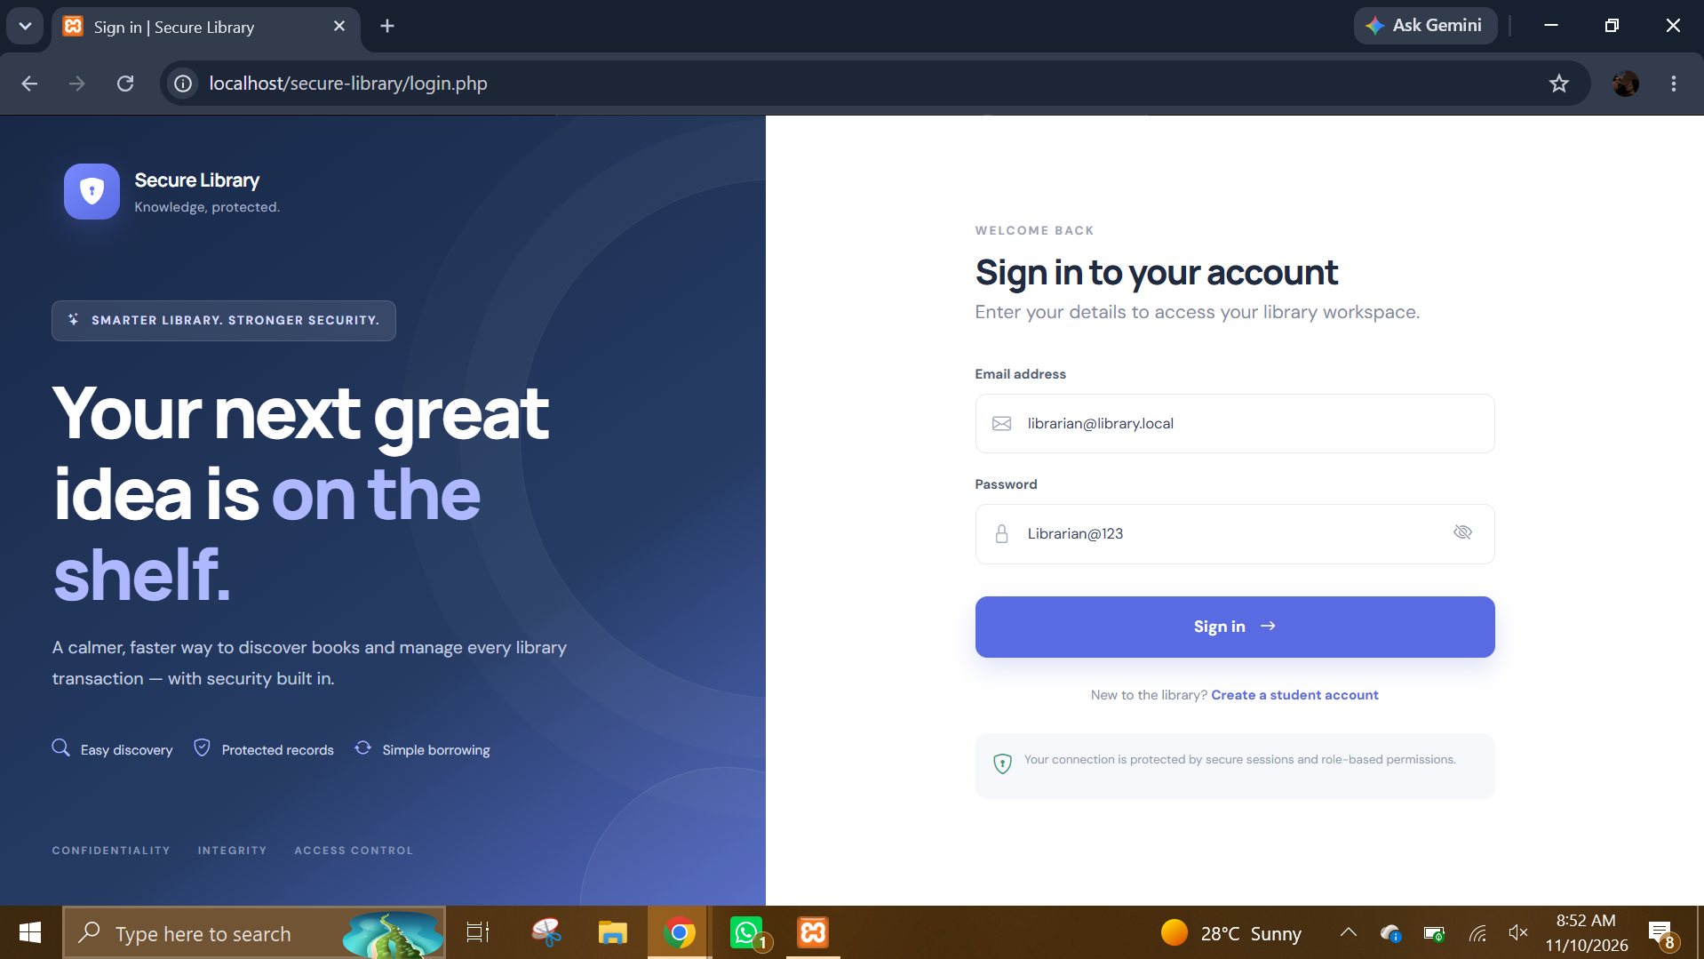
librarian 1.PNG: Librarian sign-in page. The librarian uses the same authentication interface before accessing librarian-only operations.
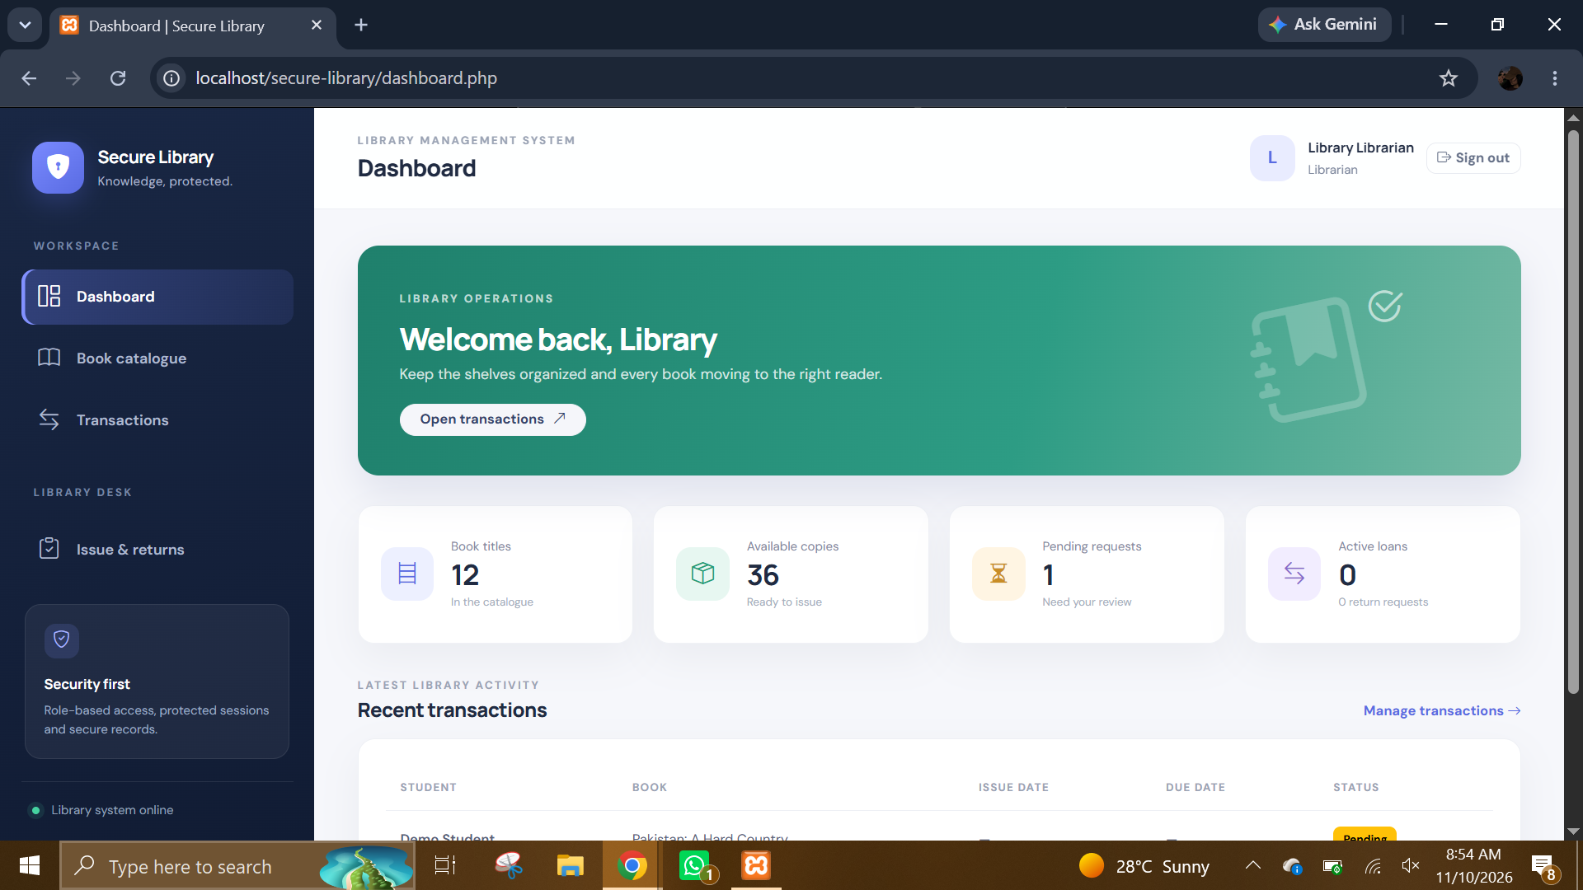
librarian 2.PNG: Librarian dashboard overview. It provides an operational summary and navigation to catalogue and transaction tasks.
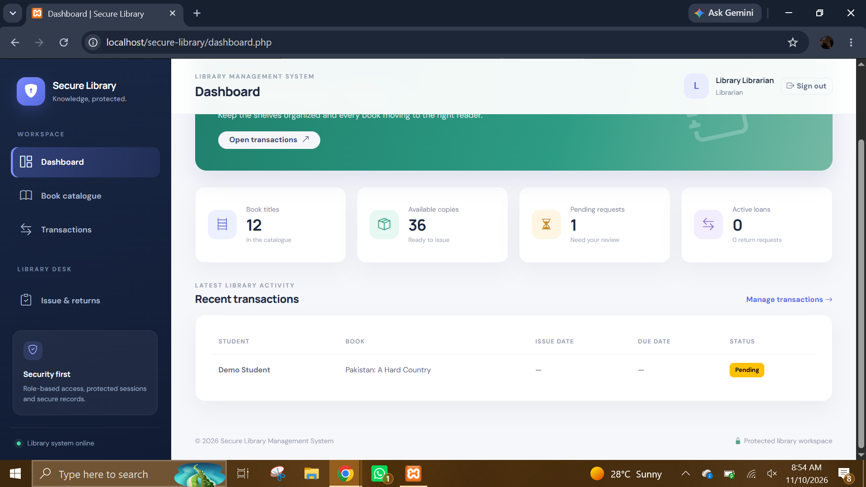
librarian 3.PNG: Librarian dashboard with recent activity and transaction information. The visible counters and recent records help the librarian monitor daily operations.
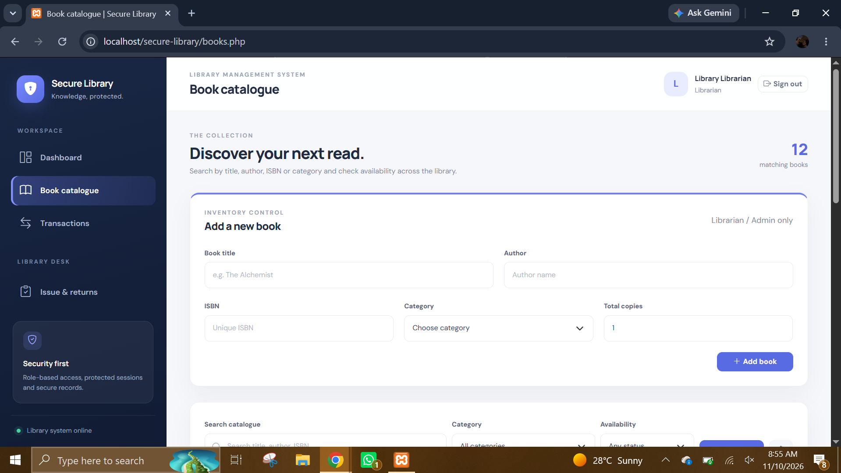
librarian 4.PNG: Book catalogue search and entry area. The librarian can search the catalogue and access the form used to maintain book records.
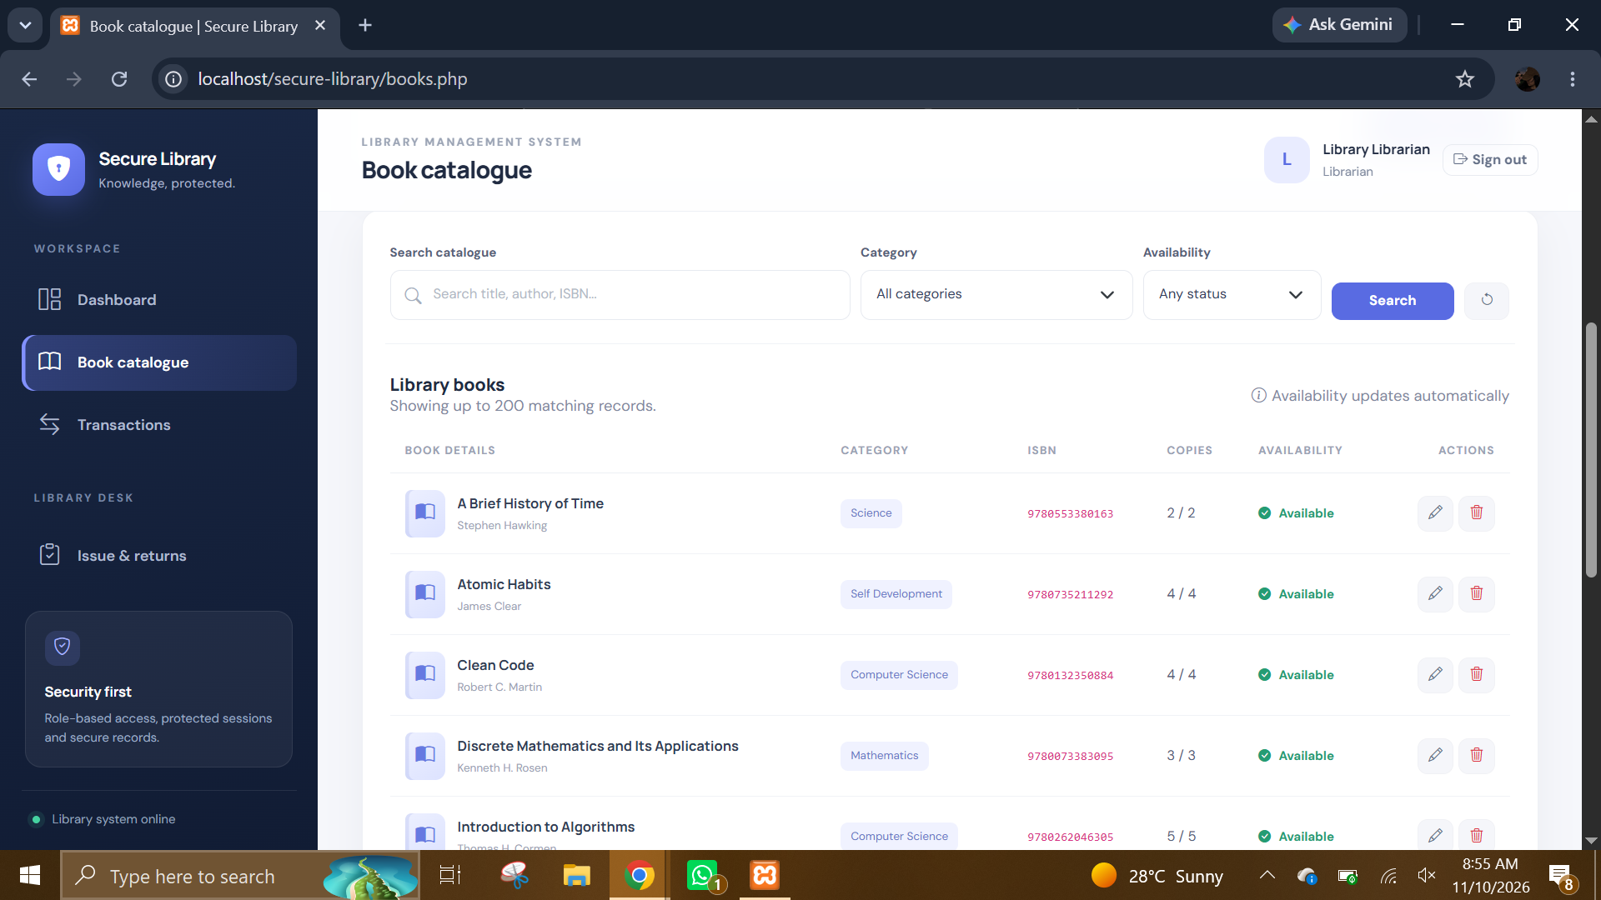
librarian 5.PNG: Book catalogue listing. The view displays book titles, authors, category/ISBN information, copy counts, and availability.
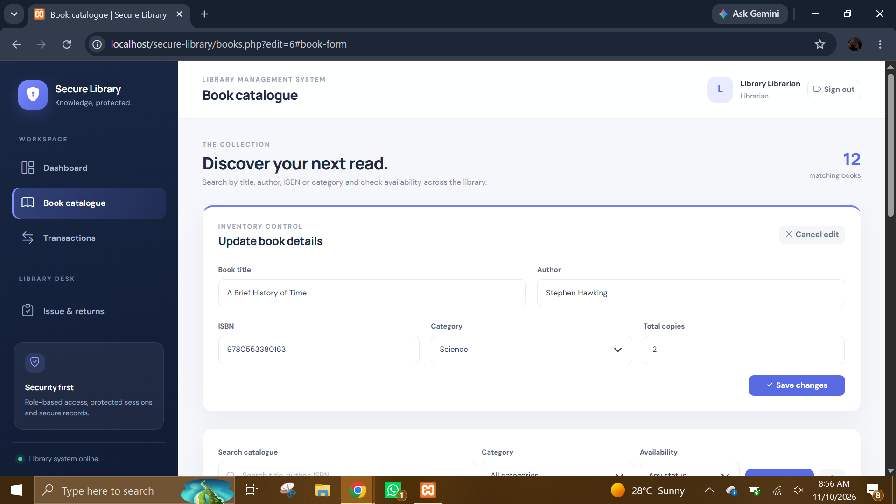
librarian 6.PNG: Edit-book view. The URL and form state indicate that an existing book record is selected for editing.
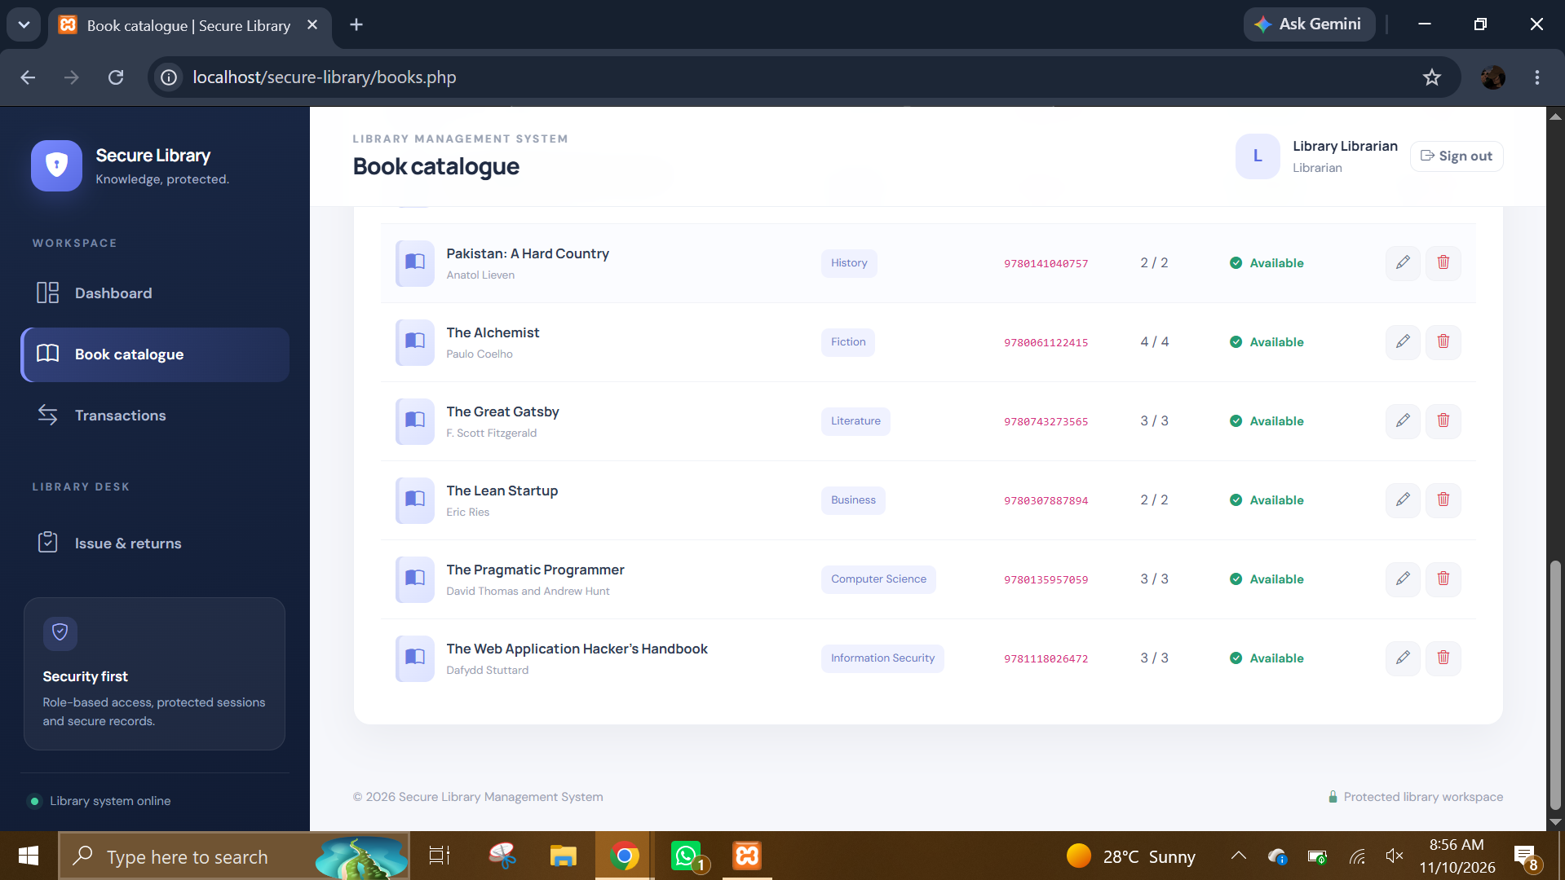
librarian 7.PNG: Catalogue list with book records. This demonstrates the librarian's inventory view and the available catalogue actions.
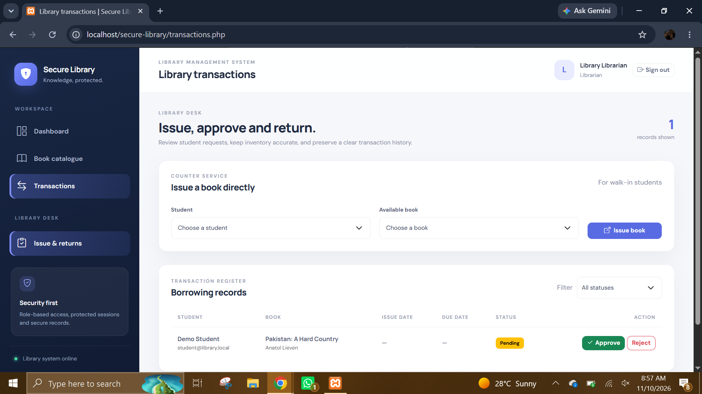
librarian 8.PNG: Library transactions workspace. The librarian can review borrowing requests and use the transaction actions to approve, reject, or record returns.
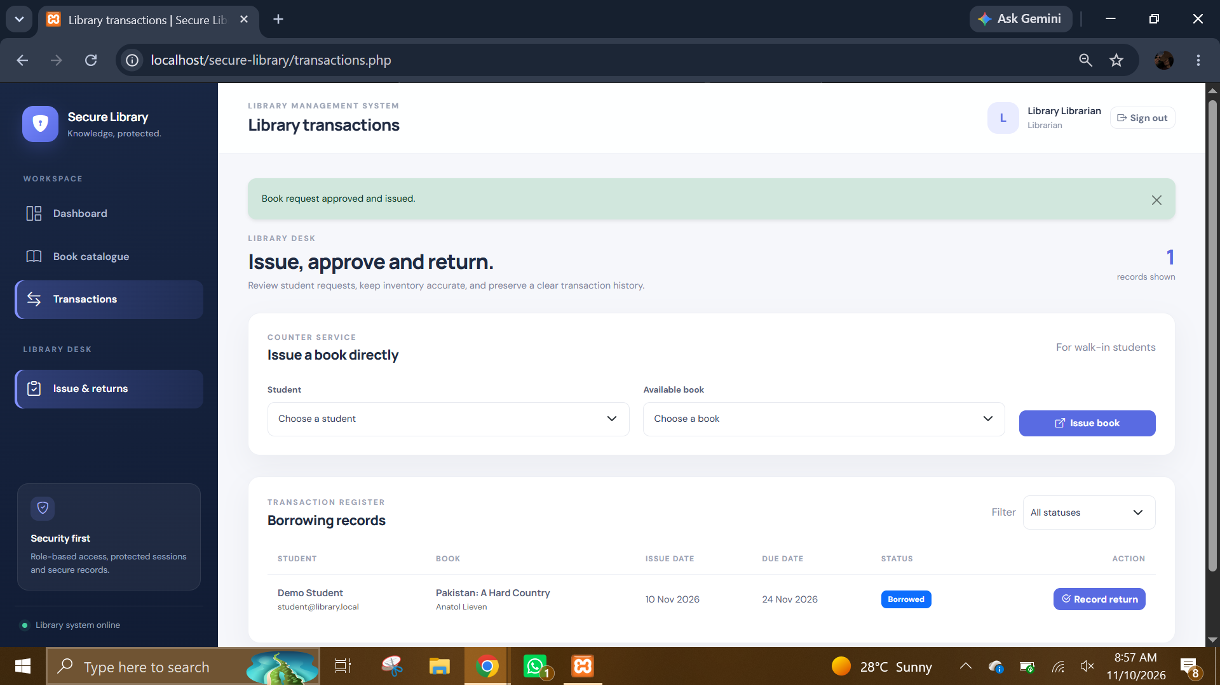
librarian 9.PNG: Library transaction register. This view displays transaction records and their statuses for operational tracking.
- Student interface
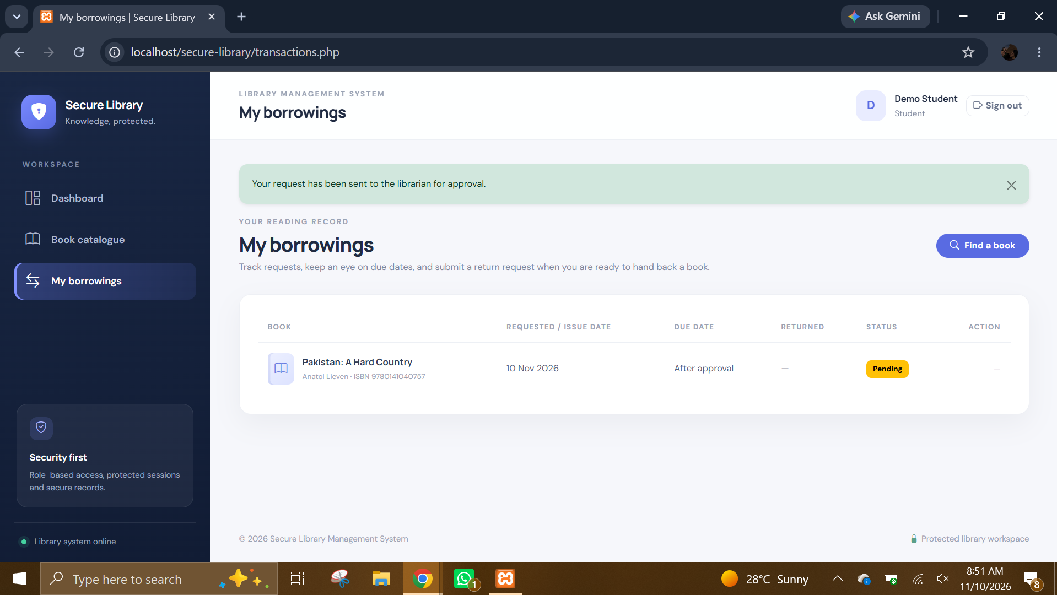
student 6.PNG: My borrowings page with request confirmation. The green confirmation message indicates that a book request has been sent to the librarian for approval.
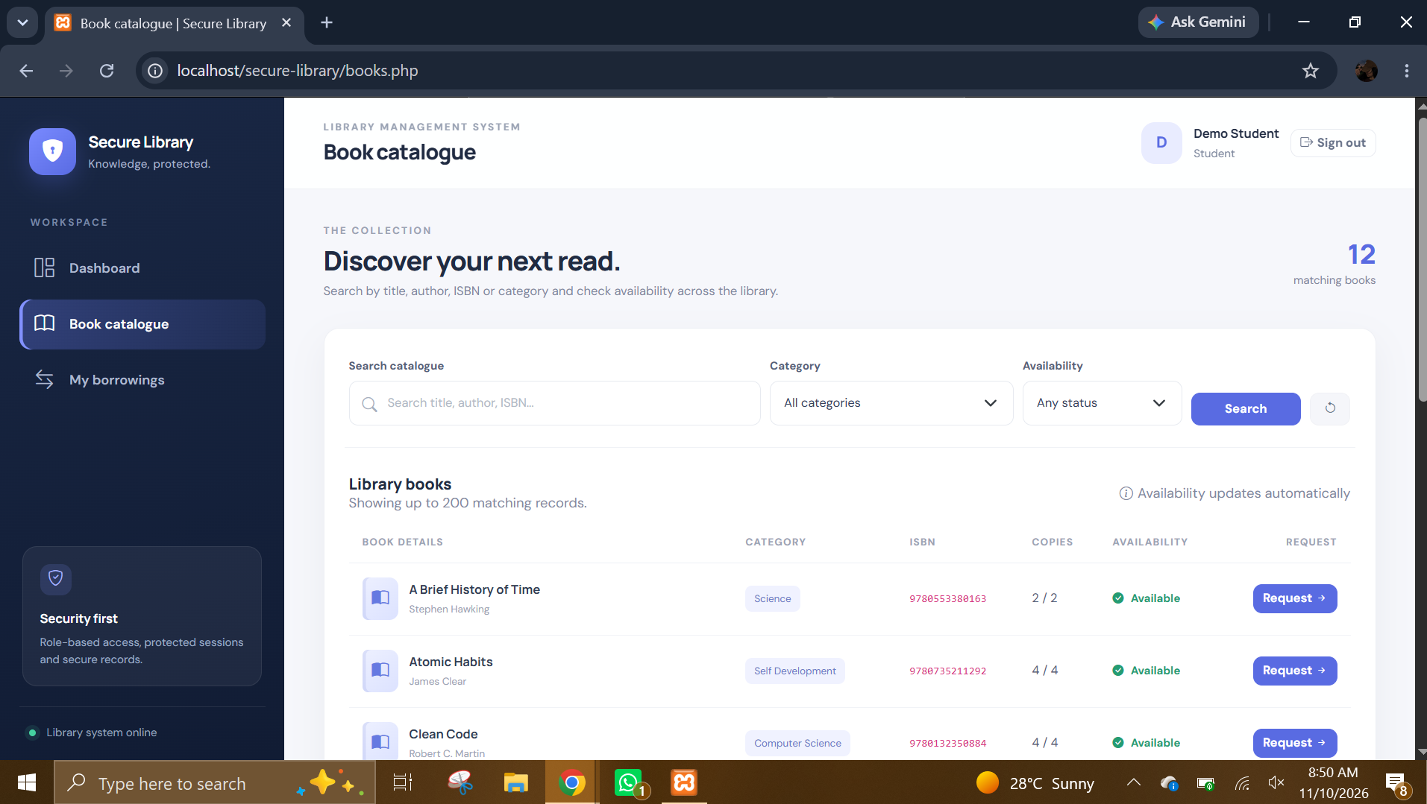
student 4.PNG: Student catalogue page. The student can search and filter the catalogue and view availability without staff-only maintenance controls.
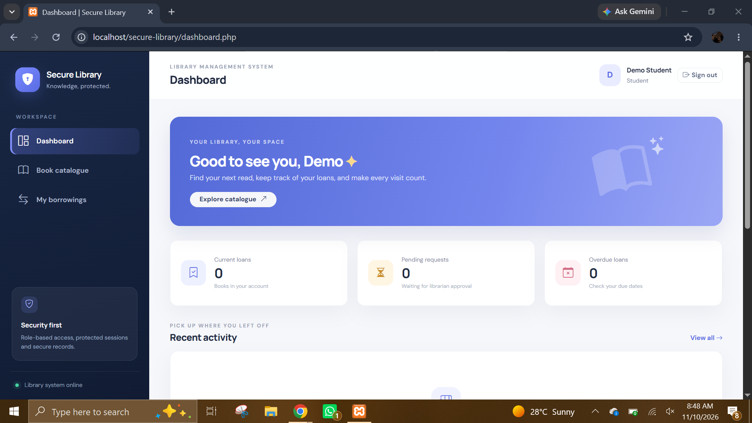
student 1.PNG: Student dashboard. The welcome panel and summary cards provide a starting point for catalogue exploration and personal borrowing activity.
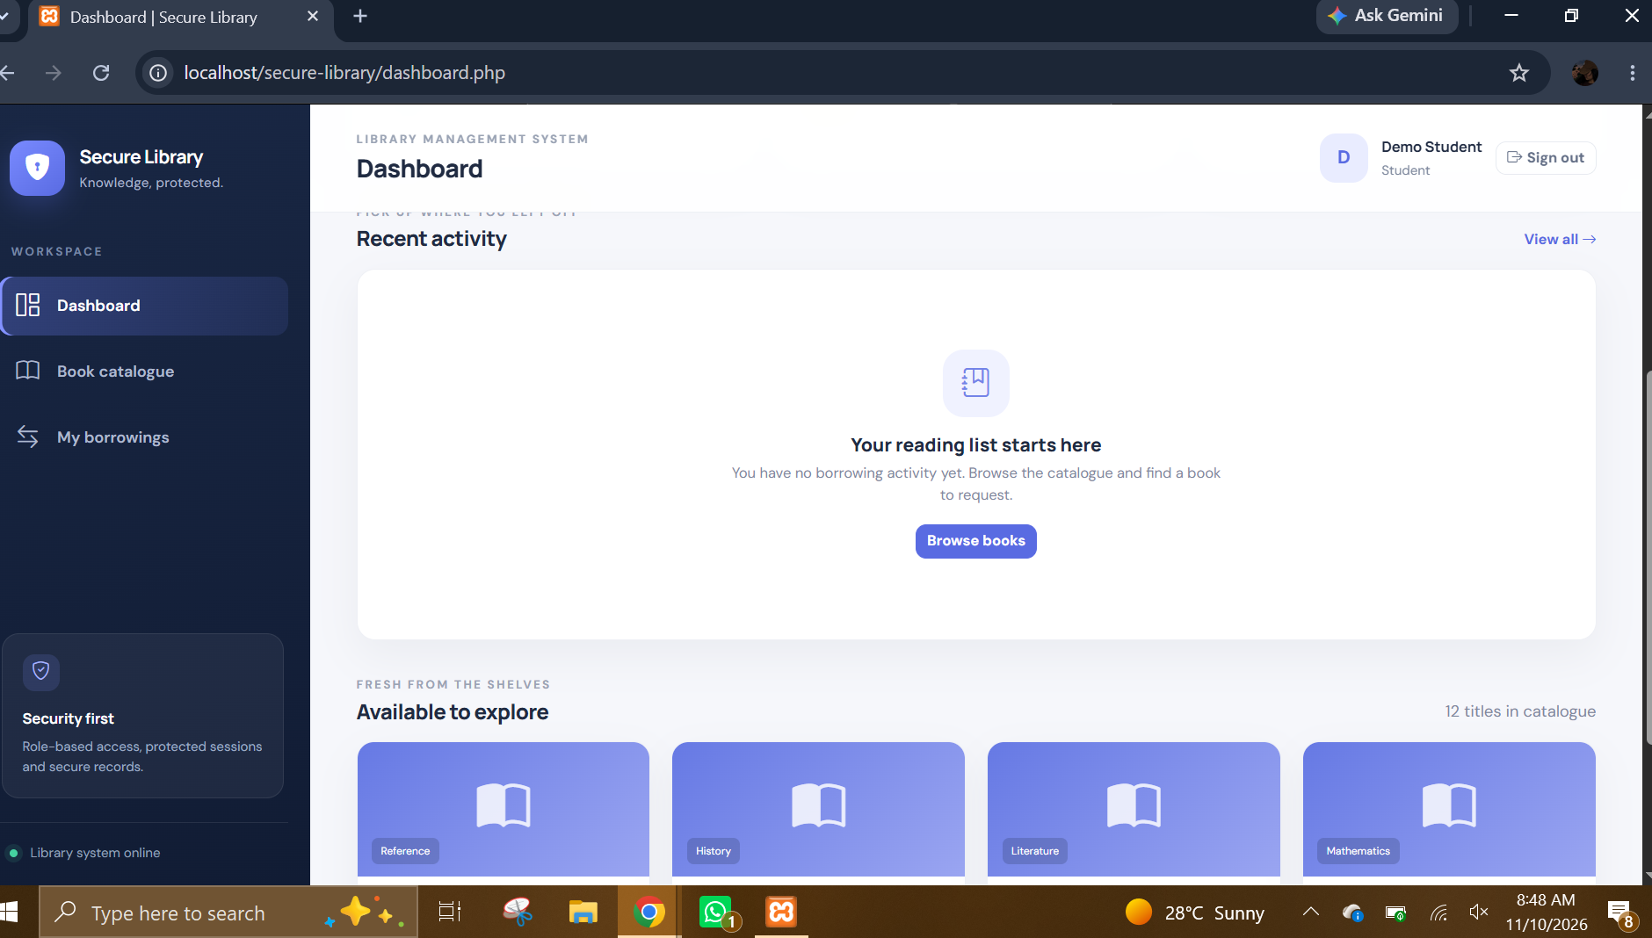
student 2.PNG: Student dashboard empty/recent-activity state. The view illustrates the dashboard when there are few or no recent records to display.
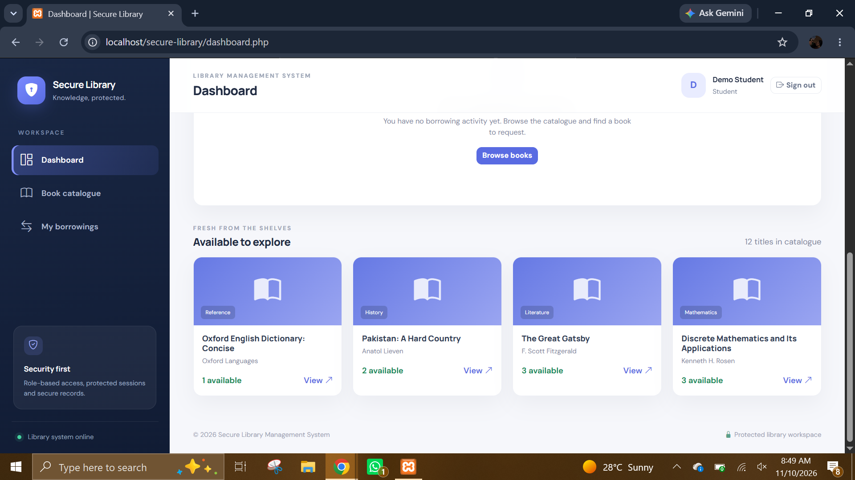
student 3.PNG: Student dashboard with catalogue availability cards. It gives the student a quick view of books available to explore.
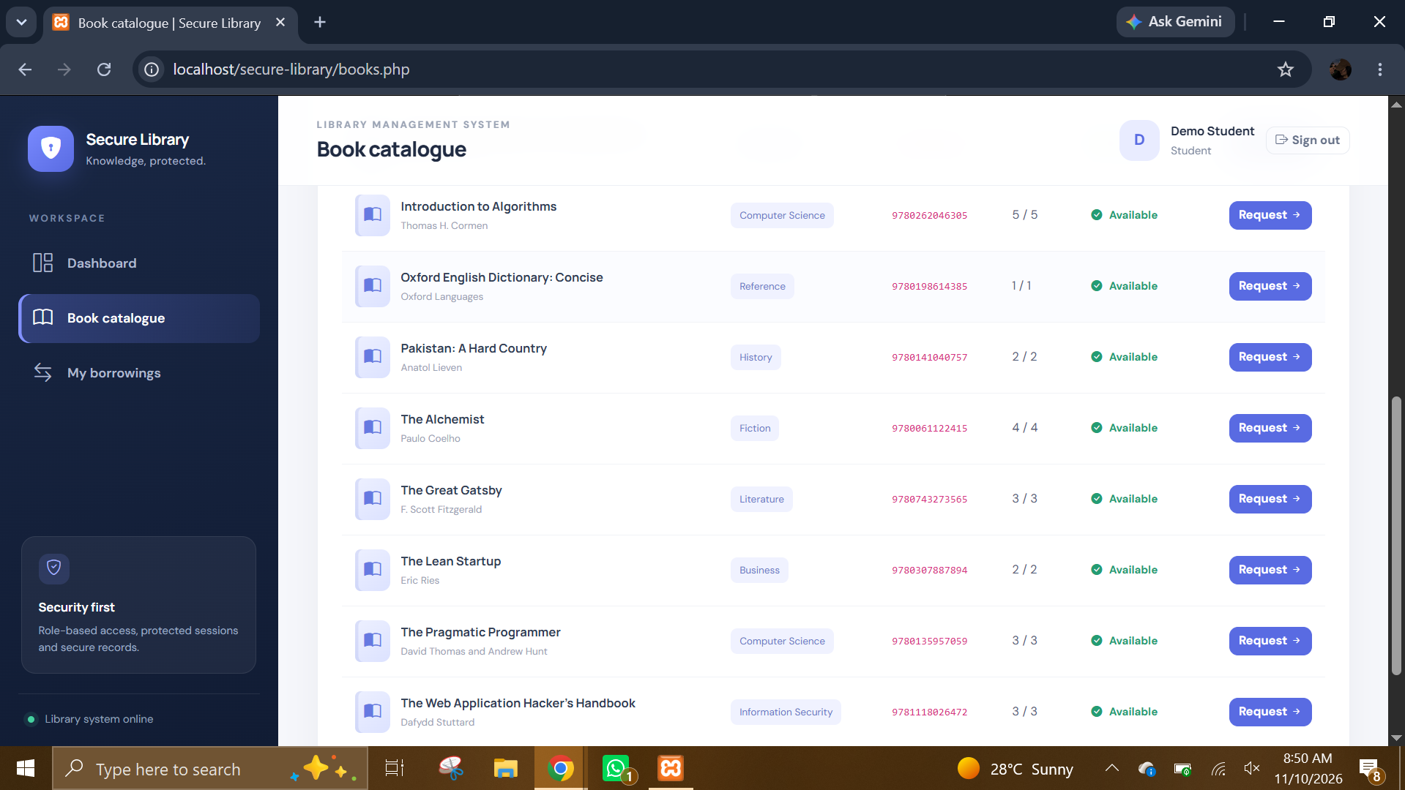
student 5.PNG: Student catalogue listing. The view shows book titles and ISBN/availability information, with borrowing actions for available titles.
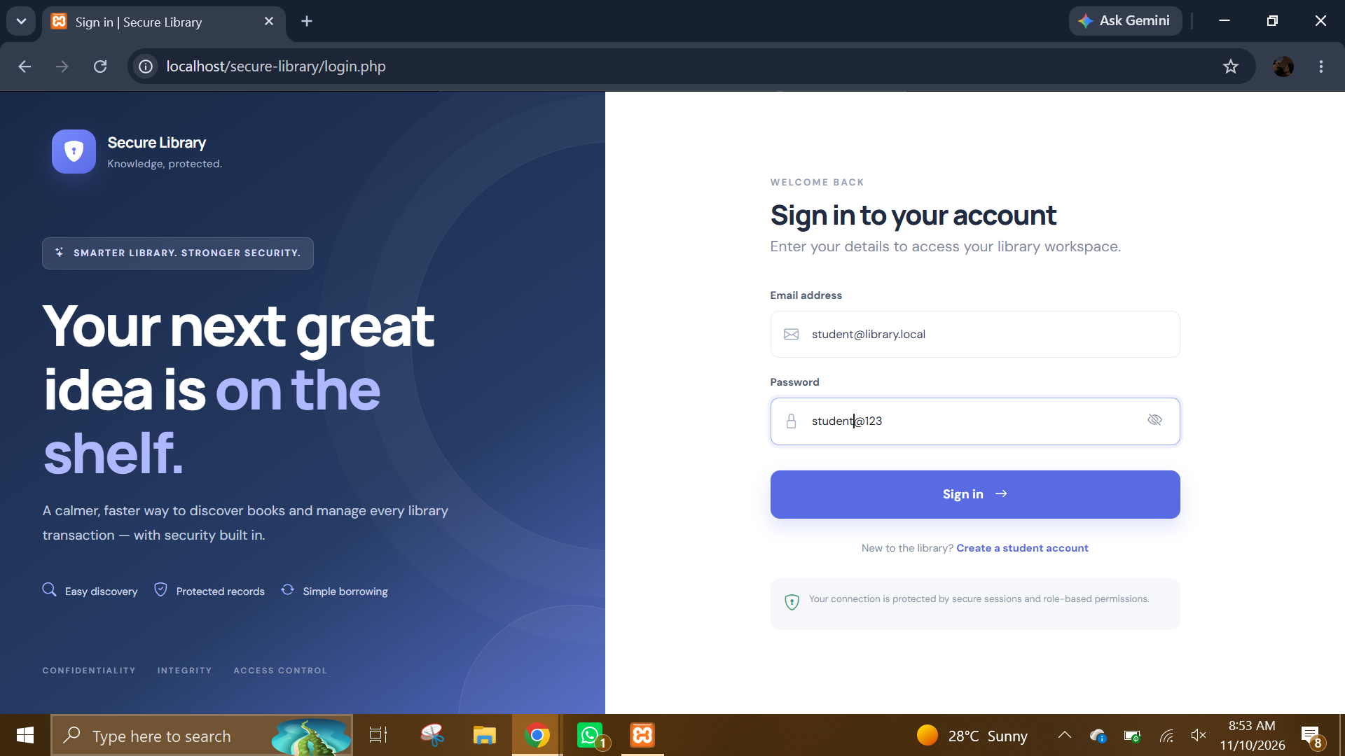
student.PNG: Student sign-in page. It is the entry point to the student workspace and is visually consistent with the other role sign-in screens.
- Conclusion
The Secure Library Management System provides a web-based foundation for managing library inventory and borrowing workflows. The delivered source code implements student, librarian, and administrator areas; a relational database; catalogue management; borrowing and return processing; account administration; configurable loan rules; reports; CSV export; and activity logging. The screenshots demonstrate the main interfaces and several important states, including registration success, invalid login, and login throttling.
The implementation reflects the proposal’s objective of reducing manual work and improving the organization of library records while applying practical information-security controls. Password hashing, prepared database statements, server-side role checks, CSRF tokens, session protections, and database integrity mechanisms are meaningful safeguards for an academic project. However, the project should remain classified as a demonstration system until deployment hardening, independent security testing, backups, and operational controls are completed.
- Github Repo Link:
https://github.com/ayeshashaikh-019/secure-library-management-system

